Algebra I Unit 5 Comparing Functions Study Guide
Name_______________________________________________Date_________________Period_________

Unit 5 Study guide Comparing Linear, Quadratic, and Exponential Functions

The tables below each represent a different function. Use these functions to answer questions 1 – 3. Label which is linear, quadratic, and exponential.

f(x) ____________________ g(x) __________________ h(x) __________________

4) If(x) = 3x - 5, find end behavior. As x ∞, y→______ and as x→-∞, y→_____

If h(x) = 3(0.8)^{x}, find end behavior. As x ∞, y→______ and as x→-∞, y→_____

_______ 5) What type of function would represent the following situation: Jack has $200 in the bank. He hopes to increase his savings by $50 a month when he starts his new job.

_______ 6) If k(x) = 4^{x +3} + 2, what is the average rate of change for the interval -2 $≤$ x $≤$ 1?
HINT: (-2, )(1, )

_______ 7) Last August, Harrison High school’s temperature was 88 degrees inside. The air conditioner cooled the building at a rate of 5% per hour. What type of function is this?

8) 9th grade at HHS had an initial enrollment of 400 and has seen an increase of 7 students each year. Write an equation: ____________________8th grade at AHS an initial enrollment of 600 and has seen a decrease in students at a rate of 8% each year. Write an equation: __________________________In how many years will both grades have approximately the same number of students ? ____________

_______ 9) Given the parent functions f(x) = 4^{x}, g(x) = 5x², and h(x) = 12x, which function is
greatest at x = 2? (HINT: find f(2), g(2), and h(2).)

________ 10) A baby bird flies up from his nest 6 feet the first second, 12 feet the next
second, 22 feet the third second, 36 feet the next second, and so on. What
type of function is this?

Directions: Use the graph to the right to select the best answer for
questions 11-12.

_______ 11) After how many years does Park A’s attendance exceed park C.
Attendance (in hundreds)
Years
Park Attendance

________ 12) Which park has the highest attendance the 8th year?

Park C

Use the following situation to select the best answer to questions 13-14. Mr. Rat Trap is catching squirrels in attics. On the first day, he collects 3 squirrels. On the second day, he collects 9 squirrels. On the third day, he collects 27 squirrels. He continues to collect squirrels at this rate for a total of 6 days.

_______ 13) How many squirrels will he collect on the 6th day?

_______ 14) What type of sequence represents the situation described?

a) arithmetic b) geometric c) quadratic d) none of these

For each of the following tables, graphs, and equations, tell whether the function is increasing linear, decreasing linear, quadratic, exponential growth, exponential decay, or none of these.
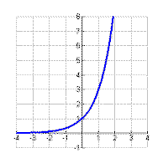
_________________ 15) _______________16) f(x) = x² + 10x -2

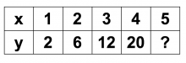
____________ 17) y = 2(0.3)^{x} __________________ 18)

____________19) g(x) = -9x + 2 __________________ 20)
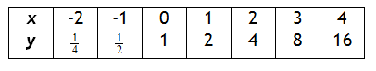

Free response

________________________________ 21) If there are 20 termites at the beginning of summer and they are tripling everyday, write an equation representing this situation. How many termites will there be after 5 days?

_______________________ 22) Write the first 3 terms of the sequence represented recursively by
a₁ = 4 and a_{n}=a_{n-1}(3). State whether it is arithmetic or geometric.

Write a new function to represent the following transformations of g(x) = x², and h(x) = 3^{x}.

_____________23) the graph g(x) reflects across the x-axis, shifts left 6, and
shifts up 5.

_____________24) the graph of h(x) down 4, shifts 3 right, and has a vertical stretch by a factor of 2.

Use the figures to answer each question. There is one quadratic, one exponential, and one linear function.
Figure A
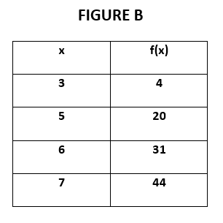
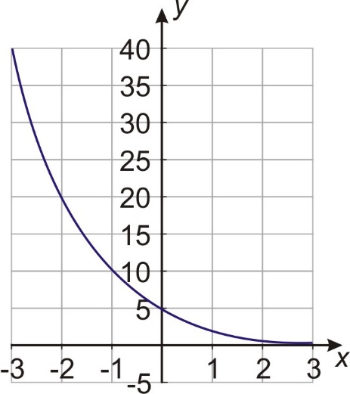

Figure C
5, 13, 21, 29, …

4 11

25) Which figure shows an exponential function? What is the equation for this function? Hint: It is a parent function with no transformations. (recall y=ab^{x} where “a” is y intercept)
Exponential Function: __________________________Equation: ___________________________

26) Which figure shows a linear function? What is the equation for this function? (recall y=mx+b where m is rate of change and b is y-intercept… aka x=0)
Linear Function: ______________________________ Equation: ___________________________

27) Which figure has the highest value when x = 6? Which figure has the lowest value when x = 6?

Highest Value Function: _______________________ Lowest Value Function: ___________________

28) Which figure has end behavior of “As x → $-∞$, y → $∞$”? ____________________

29) A population of 30 sharks are living under a pier. Each day, 5 more sharks join the school of sharks. If Sheila goes sharking fishing and catches all the sharks who live there, how many would she have caught the 5th day? What type of function is this?

30) A population of 1260 ants are living in a mound, but they caught a common cold. Every day they are losing ½ of the previous day’s population. How many ants will there be by the end of the 5th day? What type of function is this?

Potential bonus: If f(x) = -3x + 2 and g(x) = (x+3)² – 16,
1. find g(x) – f(x).

2. find f(x) – g(x)

