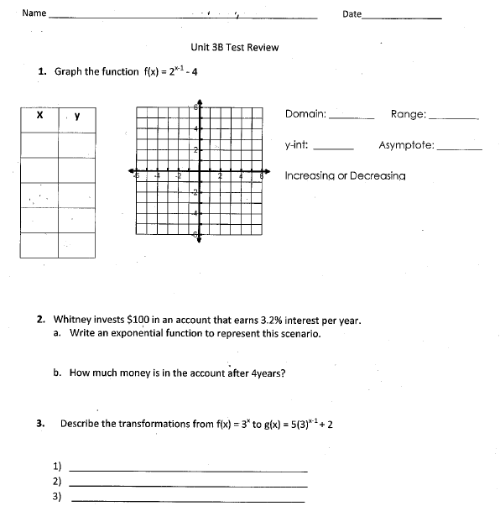
4. Using the following parent functions, write a new function given the following transformations: reflection, stretch, move left, and move down. **Answers may vary***
I. f(x) = $3^{x}$

II. f(x) = ${\frac{1}{(2})}^{x}$

III. f(x) = $5^{x}$

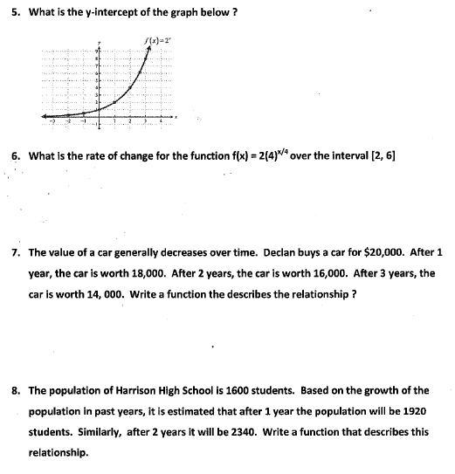

f(x) = $2{(4)}^{x-5}$ over the interval 5 ≤ x ≤ 8

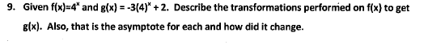

10. For each of the functions below, identify the transformations made on the parent function.
I. f(x) = $4^{x}$ to f(x) = $-({4)}^{x-5}$

II. f(x) = $3^{x}$ to f(x) =${ 2(3)}^{x+3}$+5

III. f(x) = $7^{x}$ to f(x) =${-\frac{1}{2}(7)}^{x+3}-1$

11. Annie invested $500 in to her savings account that pays 4.7% annual interest.
Write a function to model this scenario.

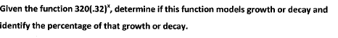
12.

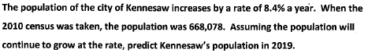
13.

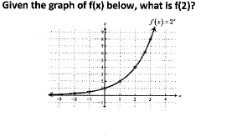
14.

