Practice Test Questions
Applications

- A limousine costs $80,000 new, but depreciates at a rate of 30% per year. What is the value of the limousine after 7 years?
  - $50,1988.14
  - $6,588.34
  - $17. 50
  - $3,282,709.39

- A culture of bacteria triples every hour. If there are 600 bacteria at the beginning, how many bacteria will there be after 10 hours?
  - 35,429,400
  - 629,145,600
  - 614,400
  - .0101361053

- Given the function$f\left(x\right)=650{(.36)}^{x}$, determine if this function models exponential growth or decay and identify the growth and decay rate.
  - Decay, 64%
  - Growth, 64%
  - Decay, 36%
  - Growth, 36%

- The value (in millions of dollars) of a large company is modeled by$f\left(x\right)=250{(1.05)}^{x}$. What is the projected annual percent growth and what is the initial value?
  - 10.5%; $250 million
  - 2.50%; $105 million
  - 250%; $5 million
  - 5%; $250 million

- The population of a small town has established a growth rate of 5% per year. If the current population is 4000, and the growth rate remains steady, how many years will it take for the population to first go over 5000?
  - 3
  - 4
  - 5
  - 6

- The population of a Russian Village is currently 600. Based on the observed growth of the population in the past years it is estimated that after 1 year the population will be 720. Similarly, it is estimated that after 2 and 3 years, the population of the village will be 864, and 1,036 respectively. Which function describes the relationship between year and the village population?
  - $f\left(x\right)=700{(1.2)}^{x}$
  - $f\left(x\right)=600{(1.2)}^{x}$
  - $f\left(x\right)=600{(1.02)}^{x}$
  - $f\left(x\right)=600{(1.2)}^{x-1}$

Practice Test Questions
Graphing and Transformations

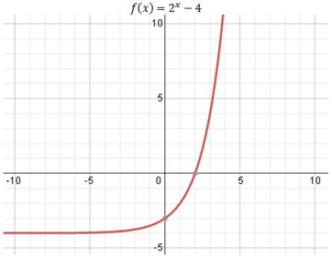

Determine the function represented by the graph above.
- $f\left(x\right)= 2^{x}-4$
- $f\left(x\right)=2^{x-4}$
- $f\left(x\right)=2^{x}$
- $f\left(x\right)= {(\frac{1}{2})}^{x}$

- Graph the function $f\left(x\right)=3({\frac{1}{2})}^{x+3}$

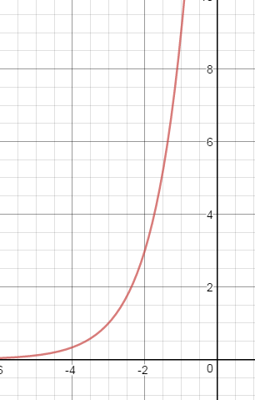
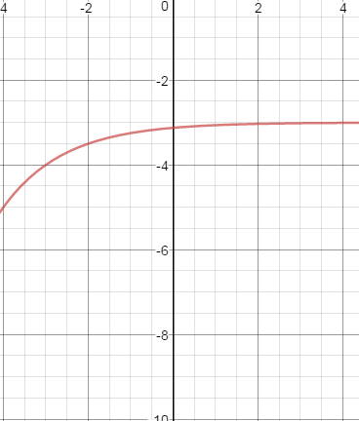
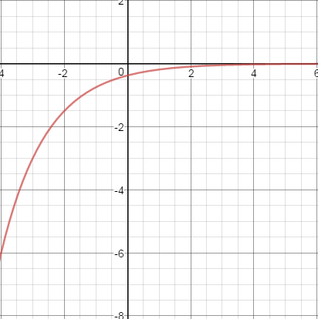
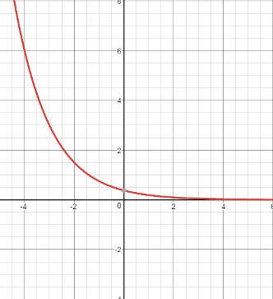
  - b. c. d.

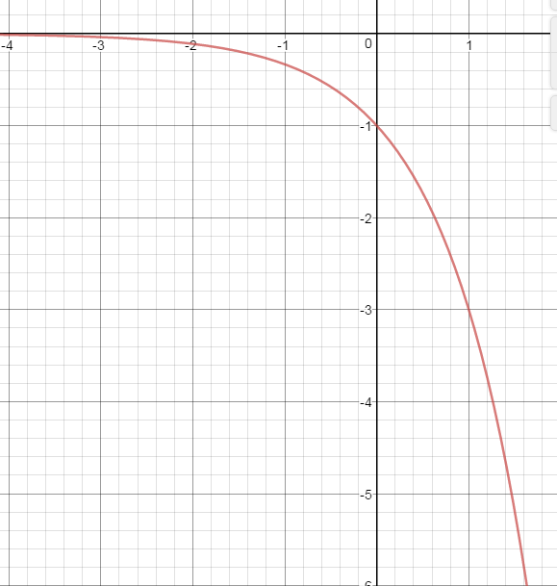

- Given $f\left(x\right)= 3^{x}$ and$g\left(x\right)= -4({2)}^{x}+4$, describe the transformations performed on f(x) to get g(x).

  - Reflection over x-axis, Vertical Stretch by a factor of 4, Vertical Shift up 4
  - Vertical Shrink by a factor of -4, Vertical Shift Up 4
  - Reflection over the x-axis, Vertical Stretch by a factor of 4, Vertical Shift down 4
  - Reflection over the x-axis, Vertical Shrink by a factor of 1/4, Vertical Shift down 4

- Which of the following equations represents a reflection over the x-axis, horizontal shift left 5, vertical shift up 12, and a shrink from the parent function f(x) = 2^{x}
  - $f\left(x\right)= 2^{x-5}-12$
  - $f\left(x\right)= {-\frac{3}{5}(2)}^{x-5}+12$
  - $f\left(x\right)= -5({2)}^{x+5}+12$
  - $f\left(x\right)= {-\frac{3}{5}(2)}^{x+5}+12$

Practice Test
Geometric Sequences

Write an explicit rule for the following sequences (questions 1 – 3):

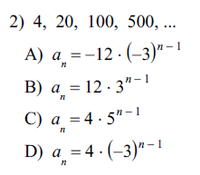
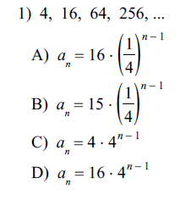

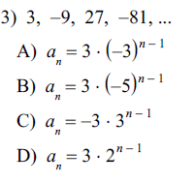

Given the recursive formula, write an explicit formula for the same sequence (questions 4-6)
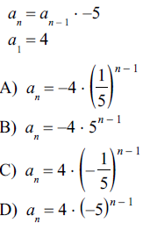
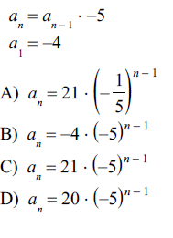
4. 5.

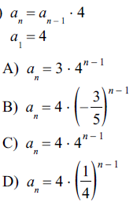
6.

Write an explicit formula and find the specific term (questions 7-8).

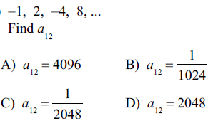
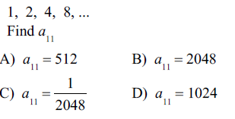
7. 8.

Practice Test Questions
Characteristics of Exponential Functions

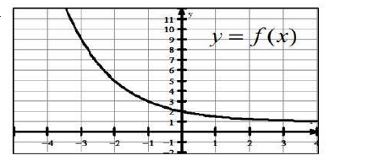

What is the average rate of change for the function f(x) on the interval [-2, 0]?
- -2
- -3
- -6
- -1.5

- What is the asymptote of the function$f\left(x\right)= \frac{1}{2}({2)}^{x}-4$ ?
- x = .5
- y = 2
- x = 4
- y = -4

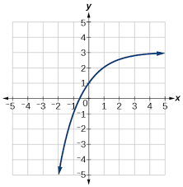

State the range of the function.
- (-∞, 3)
- (3, -∞)
- (3, ∞)
- (-∞,∞)

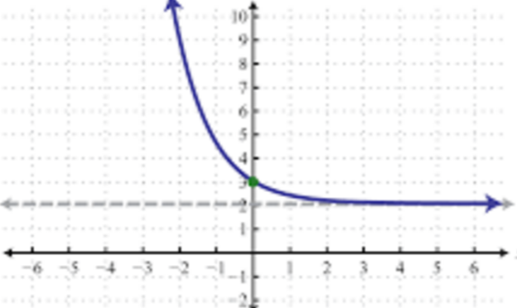
- State the range of the function.
  - (2, ∞)
  - (2, -∞)
  - (∞, 2)
  - (-∞,∞)

- Calculate the average rate of change for the function $f\left(x\right)= {2(4)}^{x-4}$ over the interval [5, 8]
  - 8
  - 168
  - 12
  - 512

- What is the y intercept of a function whose equation is$f\left(x\right)=3{(2)}^{x}$?
  - 3
  - 2
  - 1
  - 0

Which statement correctly describes part of the end behavior of the function graphed?
  - As x → ∞, y → ∞
  - As x → -∞, y → -∞
  - As x → ∞, y → -∞
  - As x → -∞, y → 3

Which statement correctly describes part of the end behavior of the function graphed?
  - As x → ∞, y → ∞
  - As x → -∞, y → -∞
  - As x → ∞, y → 2
  - As x → -∞, y → 2

