Unit 4 Exponentials
Challenge of the Day Review

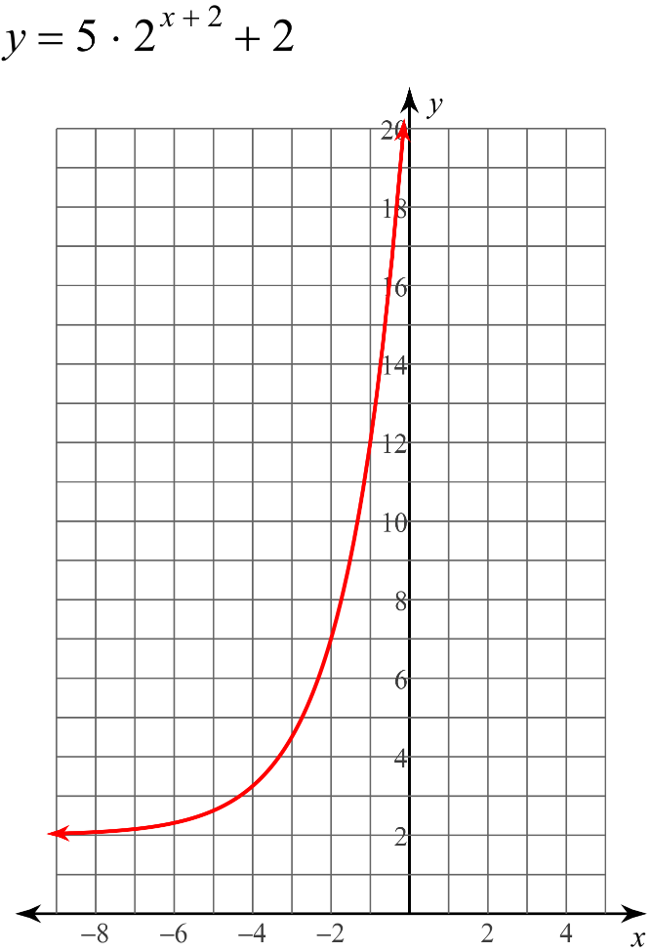
1.
Domain:

Range:

X intercept:

Y intercept:

Increasing: Decreasing:

Asymptote:

End Behavior: x - ∞, f(x) ________
x ∞, f(x) ________

f(-1) = ________________

List All Transformations:

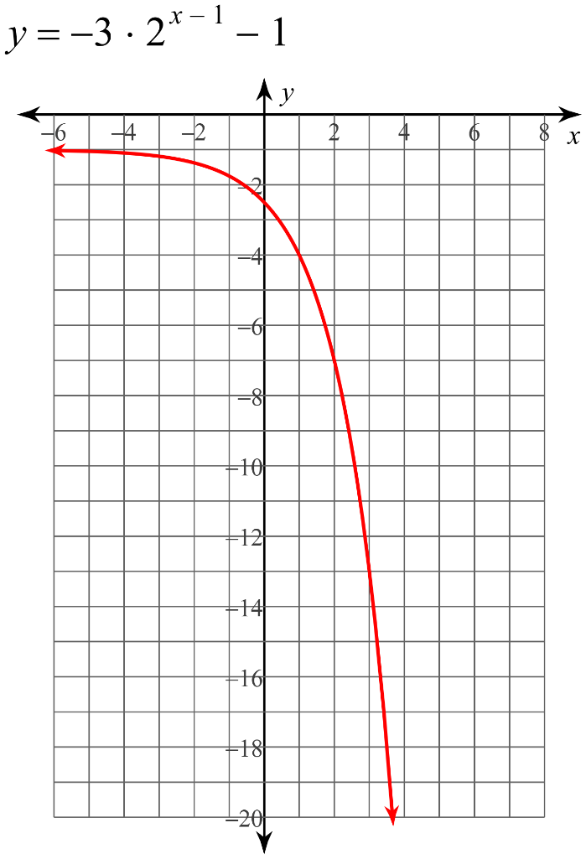
2.
Domain:

Range:

X intercept:

Y intercept:

Increasing: Decreasing:

Asymptote:

End Behavior: x - ∞, f(x) ________
x ∞, f(x) ________

f(1) = ________________

List All Transformations:

For questions 3 and 4 find the rate of change between 4 < x < 6 and determine the
y intercept.
3. 4.

5. Given the sequence:

-16, 8, -4, 2 . . . .

A. Write the explicit formula for the sequence

B. Find the 8th term.

6. Your parents buy you a car for your 16th birthday for $25,000. You plan on selling it in 10 years. If your car is depreciating at a rate of 5% each year, then how much will you be able to sell your car for?

