Unit 3 Test Review
This review requires NO Calculator
1. Determine the ratios for each trig function.
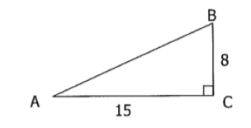
Sin A ____________
Cos A ___________
Tan A ___________
Sin B____________
Cos B ___________
Tan B ___________

2. Determine the co-function ratios for each trig function for triangle ABC. Remember the Sin $θ$ = Cos (90 - $θ$ )

A. Sin A = $\frac{12}{13}$ B. Cos B = $\frac{5}{3}$ C. Sin A = $\frac{6}{13}$ D. Cos A = $\frac{12}{13}$
Cos B = Sin A = Cos B = Sin B =

3. Solve for x using trig functions. Leave your answer unsimplified.
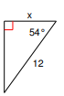
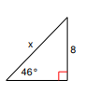
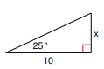
A. B. C.

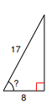
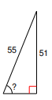
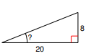
D. E. F.

