Algebra 1 Name:
Unit 2B Test Review
Part One: Checking Solutions – Systems of Equations. For the following systems of equations, determine whether the points given represent solutions.
1) $\left\{\begin{aligned}-12x+9y=7 \\ 9x-12y=6\end{aligned}\right.$ | a) $(-2, -2)$ | b) $(0, 2)$
 | yes, it is a solution  no, it is not a solution | yes, it is a solution  no, it is not a solution

2) $\left\{\begin{aligned}y=2x-3 \\ y=x-6\end{aligned}\right.$ | a) $(-3, -9)$ | b) $(-9, 3)$
 | yes, it is a solution  no, it is not a solution | yes, it is a solution  no, it is not a solution

3) $\left\{\begin{aligned}2x-y=4 \\ 3y=6x-12\end{aligned}\right.$ | a) $(3, 2)$ | b) $(-3, -10)$
 | yes, it is a solution  no, it is not a solution | yes, it is a solution  no, it is not a solution

Part Two: Determining Number of Solutions. Without solving the following systems of equations, determine the number of solutions. Justify your answer.
4) $\left\{\begin{aligned}y=\frac{1}{2}x+3 \\ y=2x-4\end{aligned}\right.$ | 5) $\left\{\begin{aligned}y=-3x \\ y=-3x+5\end{aligned}\right.$ | 6) $\left\{\begin{aligned}y=-4x-2 \\ y=\frac{5}{2}x-2\end{aligned}\right.$ | 7) $\left\{\begin{aligned}y=2x+5 \\ 2y=4x+10\end{aligned}\right.$
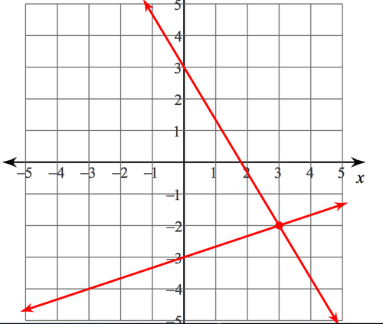
Part Three: Identifying Solutions. Identify the solution(s) to the system of equations represented.
8) 9)
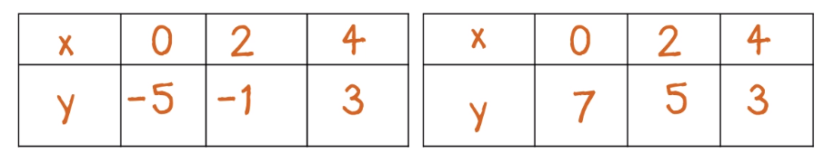

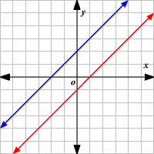
10) 11)
x | f(x) |  | x | g(x)
-1 | -5 |  | 1 | 0.5
0 | -3 |  | 2 | 1
1 | -1 |  | 3 | 1.5
2 | 1 |  | 4 | 2
3 | 3 |  | 5 | 2.5

Part Four: Solving Systems by Graphing. For the following systems of equations, solve by graphing.
12)$\left\{\begin{aligned}y=-\frac{1}{2}x-1 \\ y=\frac{1}{4}x-4\end{aligned}\right.$ 13) $\left\{\begin{aligned}y=x-3 \\ y=-2x\end{aligned}\right.$ 14) $\left\{\begin{aligned}y=-\frac{1}{2}x-4 \\ y=-\frac{1}{2}x+6\end{aligned}\right.$
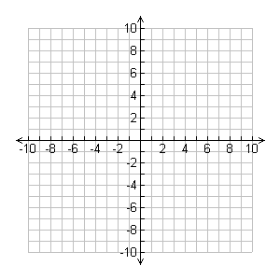

Part Five: Solving Systems by Substitution. For the following systems of equations, solve by substitution.
15)$\left\{\begin{aligned}3y-6x=24 \\ y=2x+8\end{aligned}\right.$ 16) $\left\{\begin{aligned}2x+3y=12 \\ y=-x+5\end{aligned}\right.$

17) $\left\{\begin{aligned}y=3x-2 \\ 6x-2y=-8\end{aligned}\right.$ 18) $\left\{\begin{aligned}y=3x \\ y=5x-8\end{aligned}\right.$

Part Six: Solving Systems by Elimination. For the following systems of equations, solve by elimination.
19)$\left\{\begin{aligned}-4x-2y=-12 \\ 4x+8y=-24\end{aligned}\right.$ 20) $\left\{\begin{aligned}-5x+2y=32 \\ 2x+3y=10\end{aligned}\right.$

21) $\left\{\begin{aligned}2x-6y=5 \\ 3x-9y=2\end{aligned}\right.$ 22) $\left\{\begin{aligned}3x-y=-2 \\ 9x-3y=-6\end{aligned}\right.$

Part Seven: Solving Systems – Word Problems. For the following scenarios, create and solve a system of equations to represent the given information. Be sure to define your variables and include units in your final answer.
23) Your upcoming Biology test is made up of two types of questions – questions worth five points each and questions worth 8 points each. There is a total of 22 questions on the test and totals 122 points. How many five point and eight point questions are there?

24) A movie theater sells tickets for $8 each, with senior citizens able to purchase $6 tickets. One evening, they sold 525 tickets and took in $3580 in revenue. How many of each type of tickets were sold?

25) At a local gym you want to go, you can either pay $90 for a monthly pass and then pay $4 each time you go to the gym. Alternatively, you can pay $13 each time you go to the gym with no monthly pass. After how many visits will your cost be the same? What will the cost be?

Part Eight: Choosing the Best Method. For each system of equations below, determine whether graphing, substitution, or elimination would be the best choice. Justify your answer. You do not need to solve these systems.
26) $\left\{\begin{aligned}y=7x+2 \\ 3x-8y=-1\end{aligned}\right.$ 27) $\left\{\begin{aligned}-6x+2y=12 \\ 4x-8y=-2\end{aligned}\right.$ 28) $\left\{\begin{aligned}y=-\frac{3}{4}x+2 \\ y=\frac{1}{2}x-6\end{aligned}\right.$

Part Nine: Checking Solutions – Systems of Inequalities. For the following systems of inequalities, determine whether the points given represent solutions. Then name two solutions that aren’t listed.
29) 30) 31)
□ $\left(0, 0\right)$ □ $(2, 0)$ □ $(-2, 2)$ □ $\left(3, 8\right)$ □ $(2, 7)$ □ $(-9, 9)$
□ $(0, 6)$ □ $(-6, 2)$ □ $\left(6, -4\right)$ □ $\left(-4, 6\right)$ □ $(-4, 6)$ □ $(10, 0)$
Other solutions: _________ Other solutions: _________ Other solutions: _________
_________ _________ _________
Part Ten: Graphing Systems of Inequalities. For each of the systems on inequalities below, graph the system and then name one solution.
32) $\left\{\begin{aligned}y<2x-8 \\ y<\frac{3}{4}x+2\end{aligned}\right.$ 33) $\left\{\begin{aligned}y≥-\frac{1}{2}x-5 \\ y<\frac{1}{2}x+1\end{aligned}\right.$
Solution: _________ Solution: _________

34) $\left\{\begin{aligned}y>\frac{1}{3}x+4 \\ y≤\frac{5}{2}x-7\end{aligned}\right.$ 35) $\left\{\begin{aligned}y<-\frac{4}{3}x+1 \\ y≥\frac{2}{7}x-2\end{aligned}\right.$
Solution: _________ Solution: _________

