Unit 2a Study Guide Name: ___________________
GSE Algebra I

What you need to know and be able to do | Things to Remember | Problem | Problem
1. Justify steps using properties | Associative prop  Commutative prop  Symmetric prop  Add property of =  Subtract prop of =  Division prop of =  Mult prop of =  Distributive prop | 14 = 5x – (2x + 4) original problem  14 = 5x – 2x – 4 ___________________________  14 = 3x – 4 ___________________________  18 = 3x __________________________  6 = x __________________________  X = 6 __________________________
2. Solve multi-step equations and inequalities | If variables cancel and left with false statement (4 = 6), then no solution. If true statement (4=6) then infinitely many solutions.  Flip the < > sign when multiplying or dividing by a negative | a. -4(2x- 3) = -6x - 12  b. 3x +12 = -4(-6x – 3) + 3x | c. -4x – (2x + 12) > 3x + 6  d. x - 7x – 4 > 10
3. Solve literal equations (rearrange formulas) | Isolate the variable  Multiply by the denominator when there is a fraction | a. solve for p if N = $\frac{p}{m}$ | b. solve for W if  P = 2(L + W)
4. Combining functions and function notation | Add: combine like terms  Subtract: distribute negative  Multiply: add exponents  Evaluate: substitute a number for x | 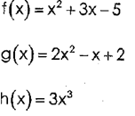  a. f(x) + g(x) | b. f(x) – g(x)  c. f(2) + h(2)
5. Arithmetic Sequences | Adding or Subtracting to get to the next term  f(n) = dn + z  a_{n} = a_{n-1} + d  a_{n} = a₁ + d(n -1) | a. 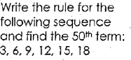 | b. 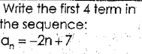  c. write an explicit formula for the table:  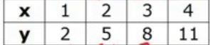
6. Graph linear functions (lines) | Write equation in slope intercept form by solving for y  Y = mx + b  b is y-intercept and m is slope (rise over run)  vertical lines:  x = a number and undefined slope  horizontal lines:  y = a number and has a slope of zero | 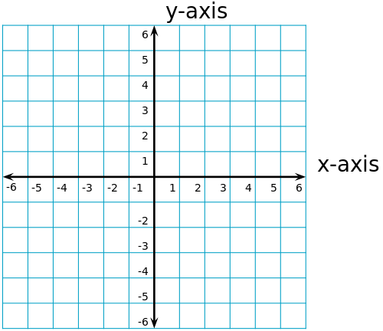  graph 3x – y = -2 | Graph y = -2/3 x -1
7. solve word problems | Consecutive integer: use x, x + 1, x + 2, etc  Consecutive even AND odd: use x, x + 2, x + 4, etc  Perimeter: draw rectangle and label sides (let x equal shortest side)  Average: add all numbers plus x and divide by number you have | a. find 3 consecutive odd integers that add up to 309. Find the integers.  b. find 4 consecutive integers that add up to 130. | c. The length of a rectangle is 3 more than twice the width. Find length and width if the perimeter is 48.  d. Bentley buys pokemon cards for $5 a pack with a service charge of $1.50. Write an equation to represent Bentley’s spending.

8. describe characteristics of linear functions | Domain: all x values  Range: all y values  X intercept: where line crosses x axis; where y = 0  Y intercept: where line crosses y axis; where x = 0  End behavior:  As x→∞, f(x) →___  As x→-∞, f(x)→___ | 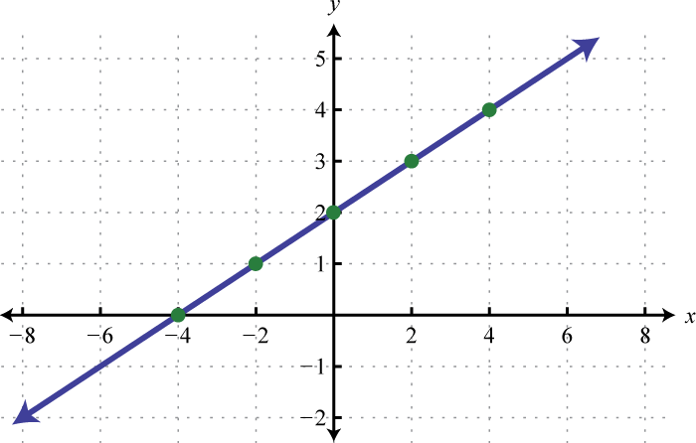  Eqn of line:_____________________  Domain:________________  Range:_________________  Y intercept:_______________  X intercept:__________________  F(2) = ________________  If f(x) = 5, then x = __________  End behavior:  As x___________________________  As x___________________________

