Name: ____________________________________ Date: _______________ Period________

What you need to know & be able to do | Things to remember | Problem | Problem
Translations | - Find the new coordinates by adding/ subtracting the given value.  - Find the pre-image by doing the OPPOSITE.  - A translation is a rigid motion which means the pre-image and image are congruent | - Translate the following points by the rule:  D (-5, 2)→_______________  O(-4, 5)→_______________  G (-1, 1)→______________  S(-4, -2)→______________ | - Translation: (x, y) → (x – 2, y – 6)  Graph pre-image and image.  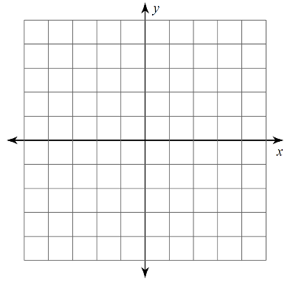  C(3, 2) A(2, 4) T(3, 5) S(5,2)
Reflections | - Reflect over x-axis: (x, -y)  - Reflect over y-axis: (-x, y)  - Reflect across y = x (switch x and y)  - Reflect across y = -x (switch x and y AND change their signs) | 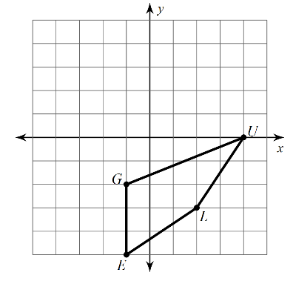  - Reflect across y = x | 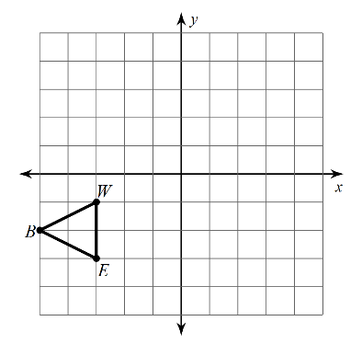  - Reflect across y = -x then reflect across the y-axis
Rotations | - 90CW/270CCW: (y, -x)  - 180: (-x, -y)  - 90CCW/270CW: (-y, x)  - “drive the car”: the fist that goes over the other is the sign that changes; switch the order. | 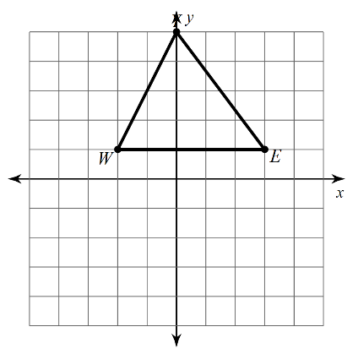  - Rotate the figure 90 CW | 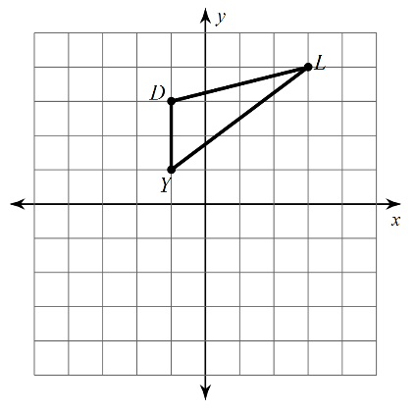  - Rotate the figure 90 CCW
Dilations | - Multiply the coordinates by the given scale factor (k)  - Pre-image and image are NOT congruent; they are similar.  - Dilations are NOT rigid motions | - A. Find the coordinates of the new vertices of the image that has been dilated by a factor of 5.  R (-4, 5)→  A(-1, 1)→  T (-4, -2)→  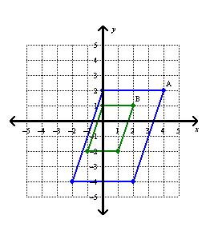  - Find the coordinates of the new vertices of the image that has been dilated by a factor of 1/2.  U(2, 4)→  R(4,-6)→  P(-2, 2)→ | - Find the scale factor of the outside image if the inside figure is the pre-image. (smaller to larger) >>> see next page
Multiple  Transformations | - ORDER IS IMPORTANT  - Use the previous ordered pairs to do the next transformation. | - Given the points  M (-3, 1) S (5, -2)  Translate: (x – 3, y + 2)  Reflect: over y -axis  M’ →  S’ →  M’’ →  S’’ → | - Given the points  K (0, -4) P (-6, -3) R (1, 2)  Reflect: over the x-axis  Rotate: 270 CCW  K’ →  P’ →  R’ →  K’’ →  P’’ →  R’’ →
Angles of a triangle | - Angles add up to 180  - The exterior angle of a triangle is equal to the sum of the 2 remote interior angles | - The angles of a triangle measure x+14, 4x – 2, and 5x +8. Solve for x and find the 3 angle measures.  X=____________  Angles ________________ | - Given the sides lengths, find the interval of the 3rd side  a. 5 and 8  b. 10 and 11
 |  | - 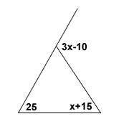  X = _________ | - 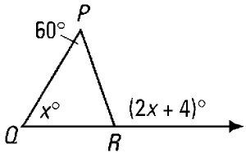  X=
Special angle relationships | - Parallel lines cut by a transversal forms congruent and supplementary angles  - Angle relationships can be vertical, adjacent, alternate interior, alternate exterior, corresponding, same-side interior, and same-side exterior. | 15.  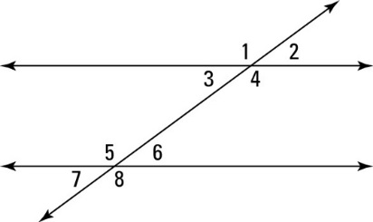  Congruent angles:  1 and _____,_____,_____  2 and _____,_____,_____  Supplementary angles:  Angle 1 and _____,_____,_____  Angle 2 and _____,_____,_____  16.If <3 = 2x + 20 and <5=3x+45, solve for x and find angles 5 and 3.  X=________  <3=_______  <5=_______  17. a. Solve for x.  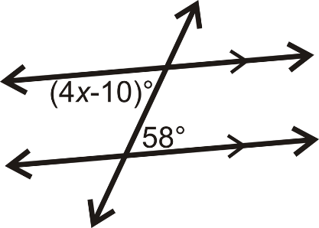  18. If m<5=110, find  m<8= ________ m<4=______  m<2=_________m<7=_______  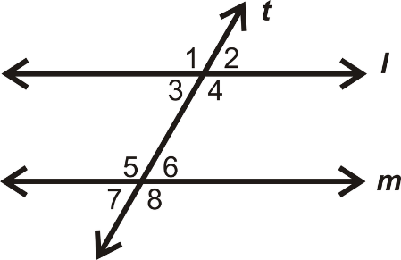 | 19.Relationships:  Angles 1and 8:  Angles1and 5:  Angles 4 and 8:  Angles 3 and 6:  Angles 7and 6:  Angles 7 and 8:  Angles 3 and 5:  Angles 2 and 8:  20. If <6 =82 and <3 =2x+10, find x and angles 6 and 3.  X=________m<6=______  m<3=________  21. Solve for x.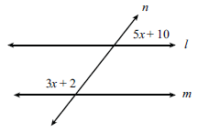  22. a. If <A = 110, find the angles the arrows are pointing to.  