Name: ________________________________________________ Date: _______________________

**Unit 3C Review**

Graph the following equation. Then, write the characteristics for the graph.

1. 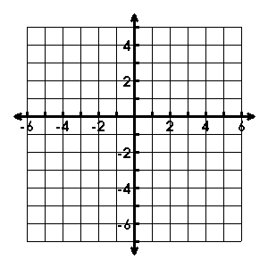 2. 

* Vertex: _______________
* Axis of Sym.: __________
* Zeroes: _______________
* Y-int: _________________
* Increase: _____________
* Decrease: ____________
* Vertex: _______________
* Axis of Sym.: __________
* Domain: ______________
* Range: _______________
* Increase: _____________
* Decrease: ____________

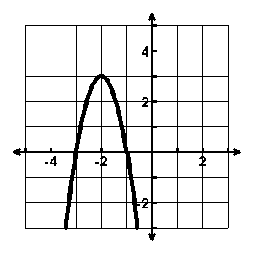

* Roots: _______________
* Avg. Rate of Change

: _____________

* Describe the transformations:

___________________________

___________________________ ___________________________

* Write the equation:

___________________________

1. 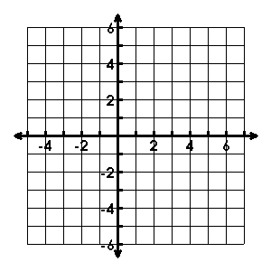Sketch the quadratic function using the given information:



Describe the transformations to the parent function in the given equations.

1. 
2. 

Write the quadratic equation of the graph that has been….

1. shifted down 1 and shrunk by a factor of 
2. reflected over the x-axis and has shifted right 2

Change the equations to standard form.

1. 
2. 

Change the equations to vertex form.

1. 
2. 
3. Compare the vertex, y-intercept, and rate of change from x1 = 1 to x2 = 2 for the following functions.

a) 

13. Megan reads about a rocket whose path can be modeled by the function

**h(t) = -16t2 + 180t + 15.** 2 points each.

a. How long will it take the rocket to reach the ground?

b. How high is the rocket after 10 seconds?

c. How long does it take the rocket to reach its maximum height?

d. What is the rocket’s maximum height?