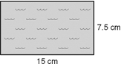
1. A diagram of a new competition swimming pool is shown. If the longer side of the pool is 25 meters, find the area of the actual pool.

2. The ratio of a model scale die cast motorcycle is 1:18. The model is 5.5 inches long. What is the length of the actual motorcycle in feet and inches?

3. Solve for x . 4.
x - 3
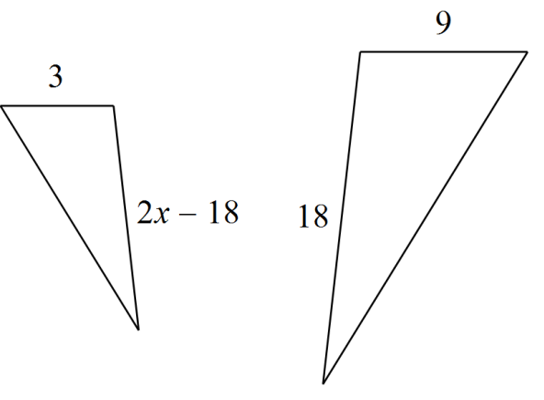

5. Determine whether the triangles are similar. If so, write the similarity ratio and a similarity statement. If not, explain why not.

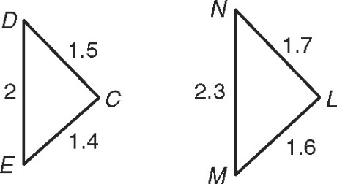
CDE and LMN

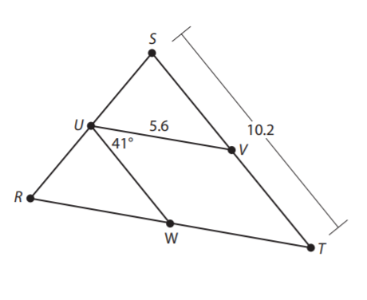

6. UV and UW are midsegments
Find the following: UW = ___________ RT = ______________
Angle STR = _________ Angle UWT = ______________
Name __________________________________

If the following Trianlges can be proved similar, state why (Postulate or theorem), and then write a similarity statement.
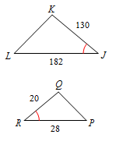
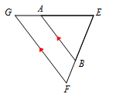
1) 2)

_________________________ ___________________________
3) 4)
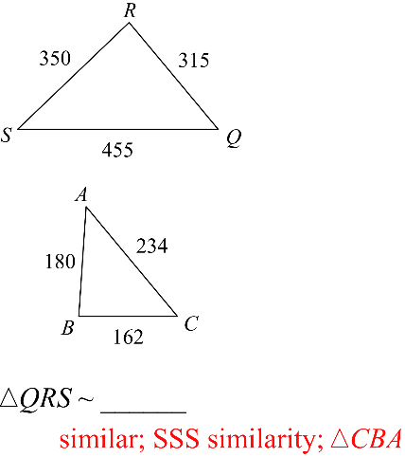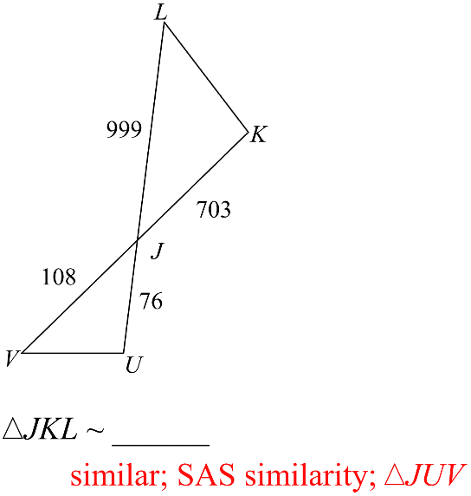
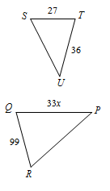
Solve for x: Show your work:
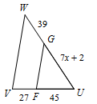
5) STU ~ RQP 6)

