**Adding and Subtracting Radicals**

Simplify each radical

Look for like radicands (same number under the house)

Combine Like Terms

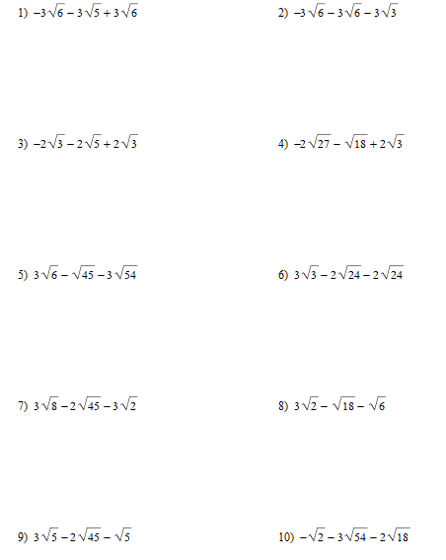

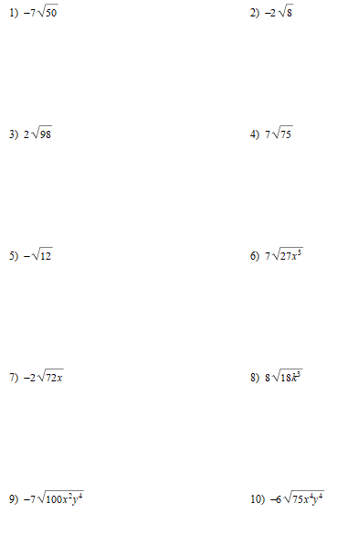

**Simplifying Radicals**

Look for perfect squares

The perfect square root goes on the outside

Imperfect things stay inside

Variables: divide the exponent by 2, evenly outside, remainder inside

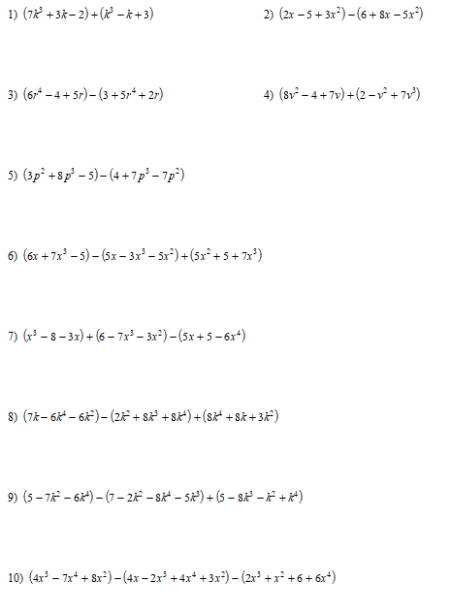

**Adding/Subtracting Polynomials**

Look to combine like terms

When Subtracting distribute the negative

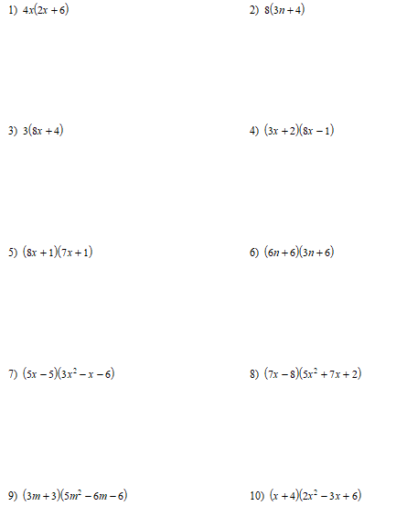

**Multiplying Polynomials**

Distribute the 1st Term

Distribute the 2nd Term

Combine like terms

**Parts of an Expression**

Coefficients Constants Terms

**Names of Polynomial by Number of Terms**

Monomial Binomial Trinomial Polynomial

**Name of Polynomial by Degree**

Linear Quadratic Cubic Quartic

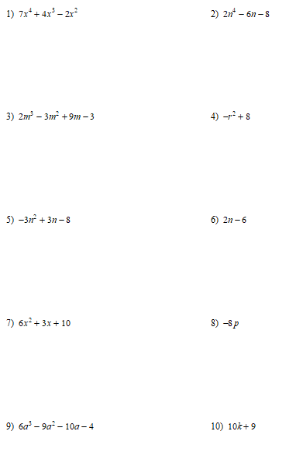

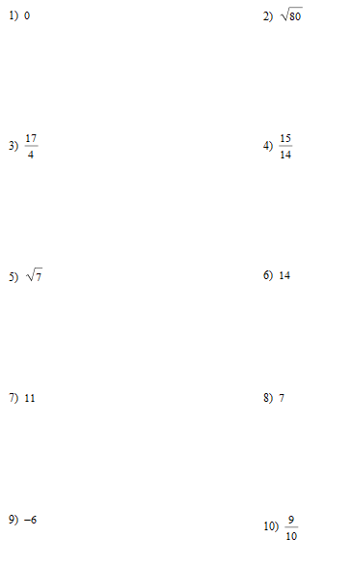

**Number System**

Real: Rational (terminating decimal with pattern, Integer, Whole Counting

Irrational: nonterminating repeating decimal

1. Convert 100 Kilometers to centimeters

2. Convert 30 Decameters to decimeters

3. Convert 0.45 meters to millimeters

4. Convert 100 centimeters to Kilometers

5. Convert 25 miles per hour to feet per second

6. Convert 30 meters per hour to centimeters per minute

7. Convert 15 jumps per minute to jumps per day

8. Convert 50 kilometers per second to meters per day

**Unit Conversions**

Start with given unit

Need diagonal units

Multiply top and bottom

Divide to Simplify

**Metric Units**

K H D b d c m

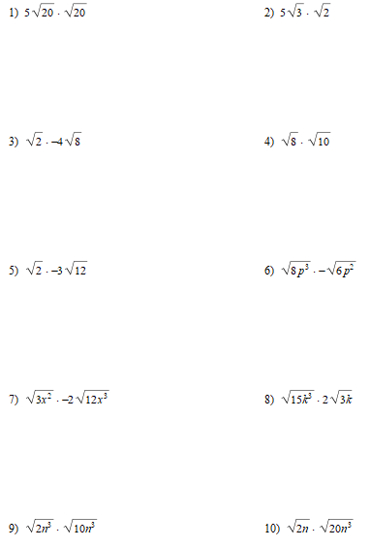

**Multiplying Radicals**

You can only multiply coefficients together

You can only multiply radicands together

Be sure to simplify