Mile One: Statistical Data

**Directions**: Complete the road blocks as a group. Correctly getting through them will advance your team one mile. Check your answers with Ms. Walsh.

1. Which of the following is one of the 5 values needed to make a box-and-whisker plot?

A. Mean B. Median C. Mode D. Mean Absolute Deviation

2. The table shows the sizes, in square feet, of a sample of eight houses from a neighborhood. House 5 is a renovated warehouse. What is the **range** of the sizes of the house?

|  |  |  |  |  |  |  |  |  |
| --- | --- | --- | --- | --- | --- | --- | --- | --- |
| **House** | 1 | 2 | 3 | 4 | 5 | 6 | 7 | 8 |
| **Size** | 1025 | 1288 | 2344 | 988 | 12,985 | 1500 | 1077 | 2455 |

* 1. 2957.75
  2. 1394
  3. 1348.5
  4. 11,997

3. Find the mean and determine if there are any outliers of the following data set.

|  |  |  |  |  |  |  |  |
| --- | --- | --- | --- | --- | --- | --- | --- |
| **44** | **33** | **18** | **20** | **26** | **26** | **24** | **17** |

A. Find the **mean**.

B. Find the **outliers.**

4. Given the data set below, what measure of central tendency should you use and why?

73, 73, 74, 75, 75, 75, 77, 77, 77, 77, 78, 78, 89, 90

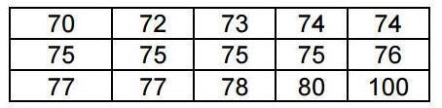5.

The data set above shows 15 students' scores on a test. Describe the shape of the data distribution if the student who scored **100 is not included** in the data set.

1. The data distribution is skewed left.
2. The data distribution is symmetric.
3. The data distribution is skewed right.
4. It is impossible to determine the shape of the data distribution.

Mile 2: Comparing Data

**Directions**: Complete the road blocks as a group. Correctly getting through them will advance your team one mile. Check your answers with Ms. Walsh.

Mr. Murray recorded the pulse rates for each of the students in his classes after the students had climbed a set of stairs. He displayed the results, by class, using the box plots shown.



1. Which class had the **highest upper quartile**?
   1. Class 1 C. Class 2
   2. Class 3 D. Class 4
2. Which class had the **lowest** **IQR**?
   1. Class 1 C. Class 2
   2. Class 3 D. Class 4

3. Which is the best description of the distribution?

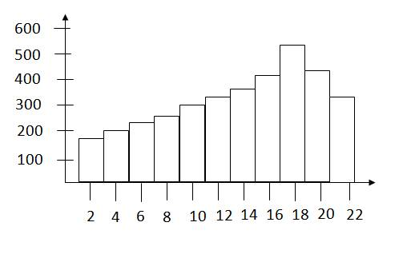

1. Bimodal
2. Symmetric
3. Skewed Left
4. Skewed Right

4. Which group has the **GREATEST** spread in the lower 25% of their data?

1. 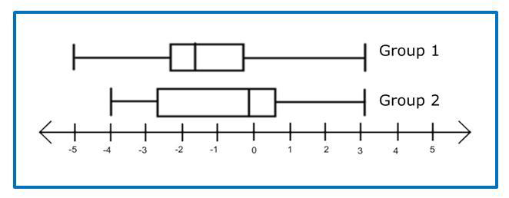Group 1
2. Group 2
3. Group 1 and Group 2 have the same spread
4. The spreads of Group 1 and Group 2 cannot be determined

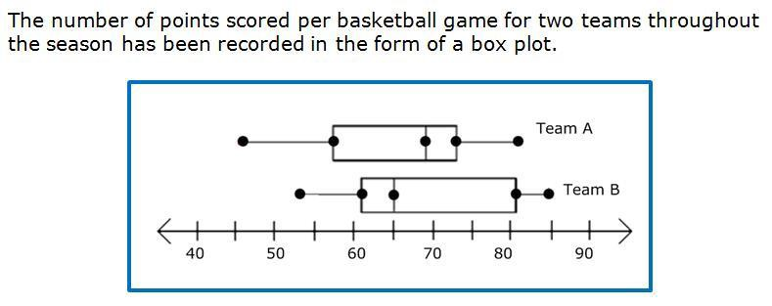5.

Which team has the **LOWEST** median for points scored per basketball game?

1. Team A has the lowest median.
2. Team B has the lowest median.
3. Team A and Team B have the same median.
4. The medians for Team A and Team B cannot be determined.

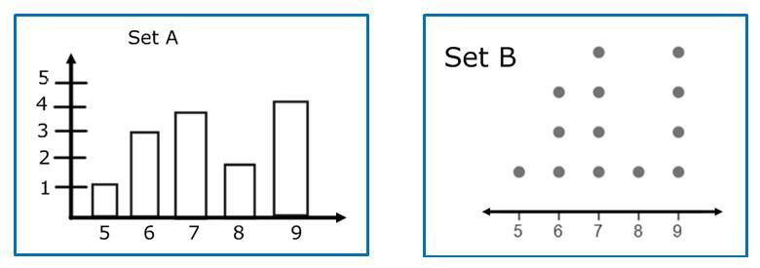6. Which set of data has the **LOWEST** mean?

1. Set A
2. Set B
3. Set A and Set B have the same mean, 7
4. Set A and Set B have the same mean, 9

Mile 3: Two Way Frequency Tables

**Directions**: Complete the road blocks as a group. Correctly getting through them will advance your team one mile. Check your answers with Ms. Walsh.

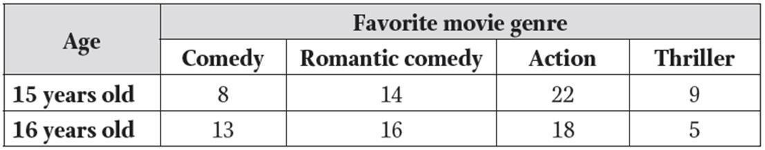

1.

Ms. Rosenberg collects information about her students. She records students’ favorite movie types in the table and separates the responses by age. What percent of those surveyed are 15 year olds who like action movies?

A. 21%

B. 42%

C. 55%

D. 51%

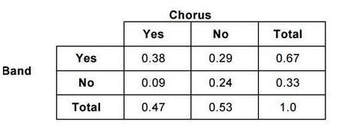2.

Gerry collected data and made a table of relative frequencies on the number of students who participate in chorus and the number who participate in band.

Given that a student is not in chorus, what is the probability that he or she is also not in band?

A. 0.29

B. 0.38

C. 0.45

D. 0.55

|  |  |  |  |
| --- | --- | --- | --- |
|  | **Science** | **Not Science** | **Total** |
| **Junior** | 150 | 210 |  |
| **Senior** | 112 | 200 |  |
| **Total** |  |  |  |

3. A group of students were polled to find out how many were planning to major in a scientific field of study in college. The results of the poll are shown in the frequency table below.

Part I: Find the **marginal frequencies** (Fill in the chart)

Part II: Out of the **juniors**, what **percent** are **not** planning to study a scientific field? (round to nearest percent)

Part III: Out of the **seniors**, what percent are pursuing a scientific field? (round to nearest percent)

Part IV: What percent of those surveyed are juniors who do not want to study science?

Part V: What percent of those surveyed are seniors who want to study science?

Mile 4: Line of Best Fit

**Directions**: Complete the road blocks as a group. Correctly getting through them will advance your team one mile. Check your answers with Ms. Walsh.

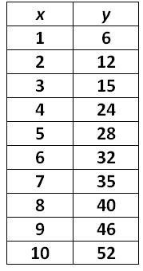1. Which linear function is a good fit for the data in the given table?

1. *y* = 5*x* + 2
2. *y = 5x – 2*
3. *y = -5x + 2*
4. *y = -5x – 2*

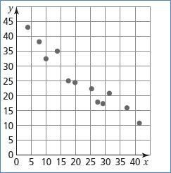

2. Which equation is the **BEST** fit for the data?

A. y = x + 47

B. y = x + 39

C. y = -x + 39

D. y = -x + 47

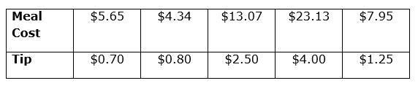3.

Which equation is the best fit line to help a waiter predict how much of a tip he might receive?

A. *y* = 0.12*x* + 0.18

B. *y* = 0.12*x* - 0.18

C. *y* = 0.18*x* + 0.12

D. *y* = 0.18*x* - 0.12

4. The data below represents the life expectancy of the population of a certain country from 1900 to 2000, based on years of birth. ***Let the year 1900 be x = 0***, and let *x* represent the number of years since 1900.

|  |  |  |  |  |  |  |  |  |  |  |  |
| --- | --- | --- | --- | --- | --- | --- | --- | --- | --- | --- | --- |
| **Year** | 1900 | 1910 | 1920 | 1930 | 1940 | 1950 | 1960 | 1970 | 1980 | 1990 | 2000 |
| **Life exp.** | 59.24 | 51.49 | 66.40 | 69.20 | 73.62 | 78.07 | 79.89 | 80.75 | 83.88 | 85.37 | 86.83 |

Part I: What is the best fitting **linear** line for the data? (round to the hundredths place)

Part II: Based on the data, what is the life expectancy for someone born in **2030**?