Name: ________________________________________________ Date: _______________________

Similarity Review Sheet

- Given, find DE and CE.
B D
A E
C
6
4
10

A model of a building has a scale of 2 in to 15 ft.
- If the model is 5 in tall, how tall is the actual building?

In the diagram, ΔCAT ∼ΔDOG. Use the diagram to find each of the following.

- Scale factor of ΔCAT to ΔDOG (Simplify if necessary)

k = _______
35˚
6
81˚
8
C
T
A

y

- Find x and y (Show Work!)

x
12
D
O
G
81˚
15
x = __________ y = __________

- Find m∠D = __________°

- Find m∠O = __________°

- Find the perimeter of ΔCAT = __________

Find the perimeter of ΔDOG = __________

- What is the ratio (scale factor) of the perimeter
of ΔCAT to the perimeter of ΔDOG? _____________

- A boy who is 5 ft. tall cast a shadow that is 12 ft long. At the same time, a building nearby cast a shadow that is 72 ft long. How tall is the building? Draw a picture!

Explain why the triangles are similar and write a similarity statement.

- ΔABC~__________ by ______
- ΔRST~__________ by ______

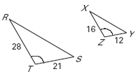
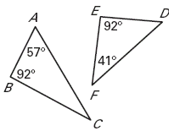

- ΔABC~__________ by ______
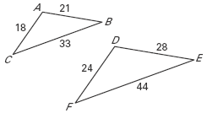

Determine which of the triangles (Δ DEF or ΔGHJ) is similar to ΔABC:
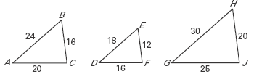

- Complete the Similarity Statement to ΔABC ~ Δ ____________

- Find the Scale Factor from ΔABC to your answer from #13. = __________

Determine whether the dilation from Figure A to Figure B is a reduction or an enlargement. Then find its scale factor and simplify if possible.

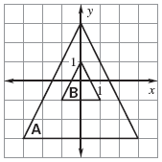
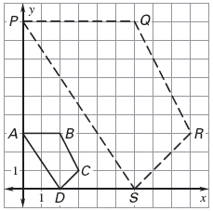
A
B

b)

Reduction or enlargement? Reduction or enlargement?

scale factor = __________ scale factor = __________

