UNIT 2B TEST TOPICS
Determine whether a given point is a solution of a system…
▫ When given equations/inequalities: substitute the (x , y) value to see if it makes the equation/inequality true
▫ When given a graph of a system of inequalities: is the ordered pair (x, y) in the overlapped shaded region

Determining the number of solutions to a system of equations…
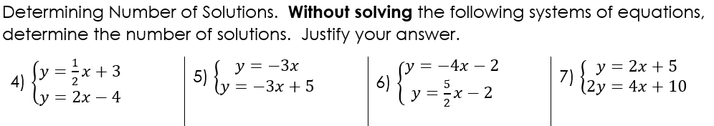

▫ Systems can have One, None, or Infinitely Many solutions
▫ Systems with 1 solution(s) have different slopes and different/same y-intercepts
▫ Systems with No solution(s) have same slopes and different y-intercepts
▫ Systems with Infinitely Many solution(s) have same slopes and same y-intercepts

Finding solution(s) to a system of equations…
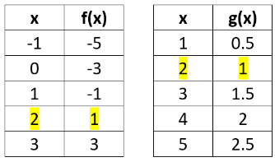
▫ When given a table of values/points: look for the same x and the same y value in each table

▫ Methods of finding the solution(s) to a system of equations: graphing, substitution, and elimination

▫ When graphing, make sure your equations are in slope intercept form y = mx + b
▫ Write your solution(s) as an ordered pair (x, y) if possible
▫ When graphing, a system with no solution will have parallel lines
and a system with infinitely many solutions will have two lines that lie
on top of one another

▫ When using substitution, at least one equation must have an isolated variable either x = ___ or y = ___
▫ When using elimination, you must find coefficients of the same variable that
are opposite signs. If there are none, you must multiply
one or both equations by a number to create two equations that can eliminate
▫ When using substitution or elimination, if both variables cancel out and you are
left with something true, there is/are infinitely many solutions and if you are
left with something false, there is/are no solution
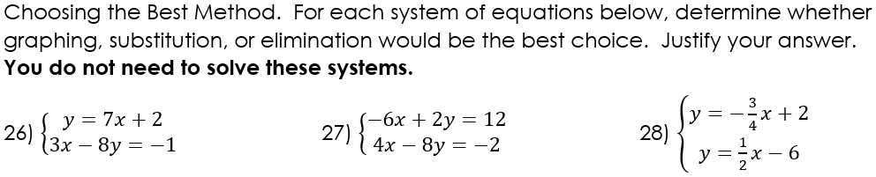

In order to find the solution(s) to a system of equations for word problems, you must:
▫ Create 2 equations to represent the given scenario
▫ Clearly define your variables
▫ Solve using substitution or eliminiation
▫ Make sure to include units with your final answers
When graphing a solution of inequalities…
▫ graph and shade your first inequality
▫ graph and shade your second inequality
▫ Solutions are where the graph is shaded (overlapped shaded region) or if two solid lines are intersecting

