Name: _______________________________________________ Date: __________________Period____________
Unit 2 Test Review

Properties:

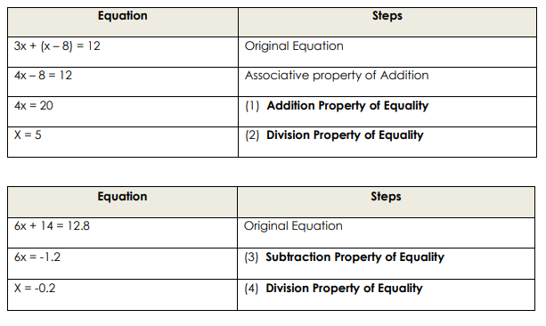

Solve the formula for the indicated variable. Show all of your work.
5. For r: V = πrh 6. For y: 7x + 14y = -21 7. For h:

Solve for x for each equation. Show all work.

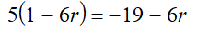
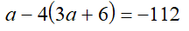
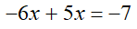
8. 9. 10.

Solve for x for each inequality. Show all work.
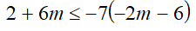
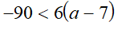
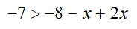
11. 12. 13.

Graph each linear equation. Identify the key characteristics for each.

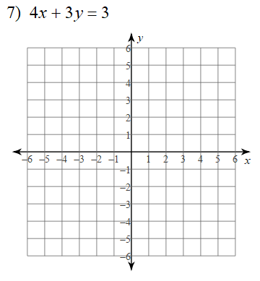
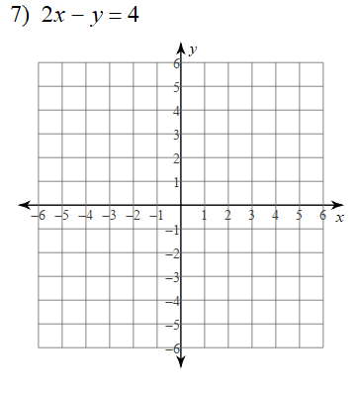
14. 15.

Slope Intercept Form:
y intercept:
Domain:
Range:
f(3):
f(x) = 4 x =
End Behavior
$x→∞ f(x)→$_______
$x→-∞ f(x)→$_______

Slope Intercept Form:
x intercept:
Domain:
Range:
f(3):
f(x) = 4 x =
End Behavior
$x→∞ f(x)→$_______
$x→-∞ f(x)→$_______

Determine if the sequence is arithmetic. If it is, find the common difference.
16. -3, -23, -43, -63, … 17. 9, 14, 18, 21, …

Given the explicit formula, find the first 3 terms and the term named in the problem.
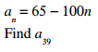
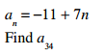
18. 19.

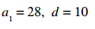
Given the first term and the common difference, write the explicit or closed form.
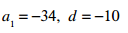
20. 21.

Given the first term and the common difference, write the recursive formula.
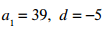
22. 23.

24. Write an expression to represent the total cost of x tickets to a fair discounted 30%.

25. Will is building a sand box for his son to play in. The length is 2 feet more than 4 times the width.
The perimeter is 224 feet. Find the length and width of the sandbox.

26. Sara wants to have an average of at least a 90 on her tests. If she took three tests and earned a
83, 95, and 88, what is the lowest grade she has to earn on the fourth test?

27. Four consecutive odd integers add up to 352. Write an equation and find the 4 numbers.

Use the two functions given to answer the questions below. $f\left(x\right)=2x^{2}-x+1$ $g\left(x\right)=3x^{2}+3x-4$

28. $f\left(1\right)+g(-2)$ 29. $f\left(x\right)-g(x)$ 30.$2f\left(1\right)+3g(-2)$

