Unit 2a Study Guide Name: ___________________
GSE Algebra I

What you need to know and be able to do | Things to Remember | Problem | Problem
1. Justify steps using properties | Associative prop  Commutative prop  Symmetric prop  Add property of =  Subtract prop of =  Division prop of =  Mult prop of =  Distributive prop | 14 = 5x – (2x + 4) original problem  14 = 5x – 2x – 4 ___________________________  14 = 3x – 4 ___________________________  18 = 3x __________________________  6 = x __________________________  X = 6 __________________________
2. Solve multi-step equations and inequalities | If variables cancel and left with false statement (4 = 6), then no solution. If true statement (4=6) then infinitely many solutions.  Flip the < > sign when multiplying or dividing by a negative | a. -4(2x- 3) = -6x – 2x - 12  b. 3x +12 = -4(-6x – 3) + 3x | c. -4x – (2x + 12) > 3x + 6  d. $\frac{2}{3}$x – 4 > $\frac{1}{2}$(6x + 10)
3. Solve literal equations (rearrange formulas) | Isolate the variable  Multiply by the denominator when there is a fraction | a. solve for p if N = $\frac{p}{m}$ | b. solve for W if  P = 2(L + W)
4. Combining functions and function notation | Add: combine like terms  Subtract: distribute negative  Multiply: add exponents  Evaluate: substitute a number for x | 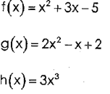  a. f(x) + 3g(x) | b. f(x) – g(x)  c. h(x) ∙ f(x)  d. f(2) + h(2)
5. Arithmetic Sequences | Adding or Subtracting to get to the next term  f(n) = dn + z  a_{n} = a_{n-1} + d  a_{n} = a₁ + d(n -1) | a. 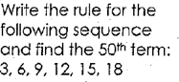 | b. 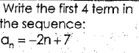  c. write an explicit formula for the table:  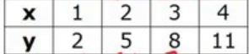
6. Graph linear functions (lines) | Write equation in slope intercept form by solving for y  Y = mx + b  b is y-intercept and m is slope (rise over run)  vertical lines:  x = a number and undefined slope  horizontal lines:  y = a number and has a slope of zero | 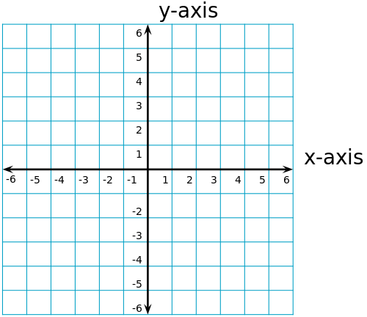  graph 3x – y = -2  Graph x + 2 = 0 | Graph y + 2 = -2/3 x + 1
7. solve word problems | Consecutive integer: use x, x + 1, x + 2, etc  Consecutive even AND odd: use x, x + 2, x + 4, etc  Perimeter: draw rectangle and label sides (let x equal shortest side)  Average: add all numbers plus x and divide by number you have | a. find 3 consecutive odd integers that add up to 309. Find the integers.  b. find 4 consecutive integers that add up to 130. | c. The length of a rectangle is 3 more than twice the width. Find length and width if the perimeter is 48.  d. Bentley chased tennis balls for 13 minutes Mon, 45 min Tues, and 60 min Wed. How many hours should he chase tennis balls Thursday to average 50 min per day?

8. describe characteristics of linear functions | Domain: all x values  Range: all y values  X intercept: where line crosses x axis; where y = 0  Y intercept: where line crosses y axis; where x = 0  End behavior:  As x→∞, f(x) →___  As x→-∞, f(x)→___ | 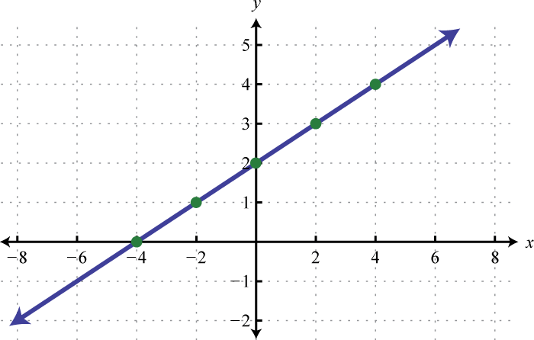  Eqn of line:_____________________  Domain:________________  Range:_________________  Y intercept:_______________  X intercept:__________________  F(2) = ________________  If f(x) = 5, then x = __________  End behavior:  As x___________________________  As x___________________________

Write an explicit equation based on the table
x | f(x)
1 | 2
2 | 5
3 | 8
4 | 11

- Solve: -5 – (15y – 1) = 2(7y – 16) – y

- Solve: $\frac{4x}{3}-4<3x+6$

- Solve: $\frac{d}{18}- \frac{1}{9}=\frac{1}{18}$

- Solve the following formula for C: $F= \frac{9}{5}\left(C+32\right)$

- Given that f(x) = 2x – 6 and the domain is {1, 3, 5}, what is the range of f(x)?

- Given that f(x) = 2x + 6 and g(x) = 7x – 2, what is (f – g)(x)?

