What you need to know & be able to do  Honors Algebra I  Unit 3 Review – Solving Quadratics | Things to remember | Examples  Name:_____________________________  Date: _______________ Period: ______
1. Solve a quadratic function by graphing | Determine where the graph crosses the x-axis.  Solution is written as x = _______.  Solutions are called:  x-intercepts  zeros  roots | a. Solve by graphing  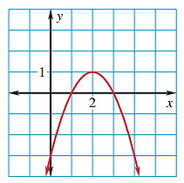 | b. Solve by graphing  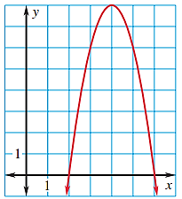
2. Determine the equation of a parabola using its zeros. | The zeros and factors in the equation have opposite signs. | a. Create an equation, in factored form, to represent the following graph.  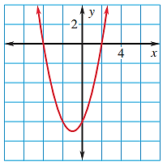  Y = | b. Create an equation, in factored form, to represent the following graph.  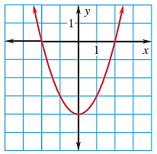  Y =
3. Solve equations in factored form. | Zero Product Property | a. Solve (x – 7)(x + 3) = 0 | b. Solve: (x – 4)(5x – 7) = 0
4. Solve equations by factoring when a = 1. | Use number diamonds if there is no number in front of x². | a. Solve x² – 9x + 20 = 0 | b. Solve x² – 6x – 16 = 0
 |  | c. x² – 13x + 47 = 7 | d. x² – 100 = 0
5. Solve equations by factoring when a is not 1 | Use the box method when the number diamond works, but there is a number in front of x². | a. Solve 5x² – 16x + 12 = 0 | b. Solve 3x² – 18x + 15 = 0
 |  | c. Solve 3x² + 2x – 8 = 0 | d. 6x² – 5x – 11 = -5
6. Solve equations by factoring GCF | Use factoring by GCF when you have two terms (a & b) and both contain an x.  One of the solutions will always be 0. | a. x² – 4x = 0 | b. $12x^{2}=-36x$
7. Solve equations by finding square roots. | Use solving by square roots when your equations have parenthesis or two terms (a & c). | a. x² = 12 | b. 8x² = 392
 |  | c. 7x² – 3 = 445 | d. (x – 4)² = 9
 |  | e. 2(x + 2)² = 72 | f. 3(x – 3)² + 2 = 26
8. Solve equations by completing the square | Move the c term to the right side  Use to complete the square and then apply square root method | 17. Solve x² + 4x + 11 = 10 | 18. Solve x² – 16x + 52 = 0
9. Solve equations by using Quadratic Formula | Use Q.F. when the equation is in standard form and number diamonds does not work.  $$x=\frac{-b±\sqrt{b^{2}-4ac}}{2a}$$ | a. x² + 10x + 15 = 0 | b. 2x² + 10x = 1
 |  | c. 3x² + 6x + 3 = 0 | d. 8x² -4x + 7 = 2
10. Use the discriminant to determine the number of solutions | Discriminant:  b² – 4ac  If the discriminant is:  Positive: two real  Zero: one real  Negative: zero real | a. Calculate the discriminant and tell number of solutions:  6x² + 2x + 1 = 0 | b. Calculate the discriminant and tell how many times it will cross the x-axis.  6x² – 7x – 3 = 0
11. Determine the best method for solving quadratic equations. | Use graphic organizer to determine the best method for solving each equation. | a. x² – 9 = 5 | b. 6x² + 8x + 1 = 0
 |  | c. 3(x + 5)² = 64 | d. 5x² – 7x = 0
 |  | e. x² + 12x + 30 = -5 | f. 3x² + 13x + 12 = 0
 |  | g. 5(x – 2)² = 125 | h. 5x² – 3x – 1 = 7
 |  | i. x² – 16 = 0 | j. x² – 15x + 56 = 0

