Name ____________________Period_______Date_________ Unit 3 part B Practice Test

1) Describe the end behavior for each function below.

a) y = x² – 6x + 11 b) –x² + 4x – 6

x ∞, f(x) ______ x ∞, f(x) ______
x -∞, f(x) ______ x -∞, f(x) ______

2) What is the vertex form of the quadratic y = 3x² – 6x + 1?

a) y = $\frac{1}{3}$(x – 1)² – 2 b) y = 3(x – 1)² – 2 c) y = (x + 2)² – 1 d) y = 3(x + 1)² – 2

3) Which of the following is NOT true of f(x) = –2(x – 4)² + 30?
- It has an axis of symmetry of x = 4.
- It has a maximum of 30.
- It has a y-intercept of (0, 30).
- The end behavior is that y → $-∞$ regardless of whether x → $-∞$ or x → $∞$.

5) Which of the following is NOT true of the function graphed below:
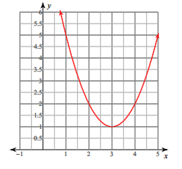
- The interval of increase is (1, $∞$).

- a = 1

- The function is y = x² – 6x + 10.

- It has a minimum value of 1.

6) Determine the domain and range of the function in question #5.
a) Domain: All Real Numbers, Range: All Real Numbers
b) Domain: (-∞, ∞), Range: [3, ∞)
c) Domain: All Real Numbers, Range: y ≥ 1
d) Domain: (-∞, ∞), Range: (-∞, 1]

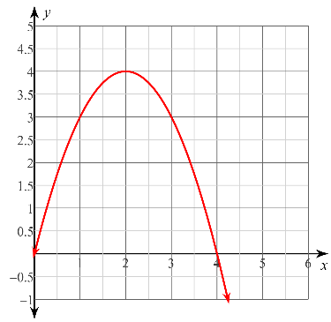
7) Find the equation of the parabola on the right.
a) y = x² + 4
b) y = -x² – 4
c) y = x² -4
d) y = -x² + 4

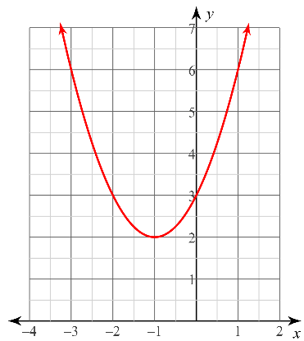
8) Write the equation of the quadratic equation in the graph.

9) Write the quadratic equation whose vertex is at (-4, -6) and is reflected over the x- axis.

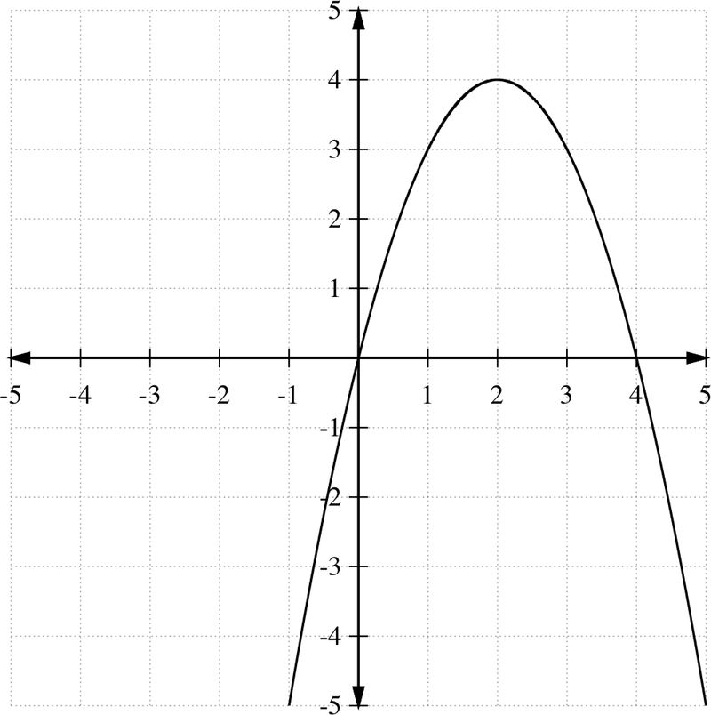
10) a. Vertex: __________
b. Axis of Symmetry: ____
c. domain: _________ range: _______
d. interval of increase___________
e. interval of decreases__________
f. max/min value_____
g. zeroes__________________
h. find rate of change 0<x<3_______

i. as x→∞, y→________
as x→-∞, y→________

11) For the function f(x) = (x + 3)² – 9, what is the value of x where the function changes from decreasing to increasing? __________

12) If the graph of y = x² is vertically stretched by a factor of 2, reflected over the x axis, translated right 7 and down 9, what would be the equation of this transformed graph?

a) f(x) = -½(x – 7)² – 9 b) f(x) = -2(x – 7)² - 9 c) f(x) = -2(x + 7)² – 9

d) f(x) = 2(x + 7)² - 9 e) none of these

13) What is the axis of symmetry of y = 2(x – 3)² – 18
a) x = –3 b) x = 3 c) x = –6 d) x = 6

14) Circle all that are true: The axis of symmetry ALWAYS contains these points: vertex, max/min, y-intercept, x-intercepts, the midpoint of x-intercepts.

15) Describe the transformations performed on the parent function y = x² to the function
y = -(x -4)² + 3

16) Does the function have a max or a min and what is its value for the quadratic equation:
y= -x² – 8x + 5

a) minimum at 5 b) maximum at 21

c) minimum at 21 d) maximum at 5

17) Given standard form, convert to vertex form AND given vertex form, convert to standard form.
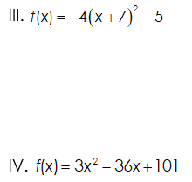
I. f(x) = (x + 2)² – 1

II.

18) A rectangular painting has an area of (2x² + 8x + 6) cm². Its length is (2x + 2) cm. Find the width.

19) A square parking lot has an area of (4x² + 20x + 25) ft². What is the length of one side of the parking lot?

20) A ball is hit into the air from a height of 4 feet. The function h(t) = -16t² + 120t + 4 can be used to model the height of the ball where t is the time in seconds after the ball is hit.

a. about how long is the ball in the air? (in other words, how long before the ball hits the ground ;))

b. What is the maximum height the ball reaches?

21) A mileage formula (miles per gallon) for a new car is f(x) = -0.03x² + 2.4x – 30, where x is speed in miles per hour.

a. At what speed x is the maximum miles per hour for this car?

b. What is the maximum miles per gallon at this speed?

c. What is the axis of symmetry of the graph of this function?

d. What is the y-intercept of this function? (hint: where x = 0)

22) Elizabeth reads about a rocket whose path can be modeled by the function
h(t) = -16t² + 180t + 15.

- What is the initial velocity and launch height? Velocity = _______ height=_______

- How high is the rocket after 5 seconds?

23) Solve each quadratic inequality

- y > x² – 6x + 11

- y < –x² + 4x – 6

- y $≥$ –x² – 4x – 2

