Name: __________________________________________ Date

**State the characteristics for the given graph.**

1. 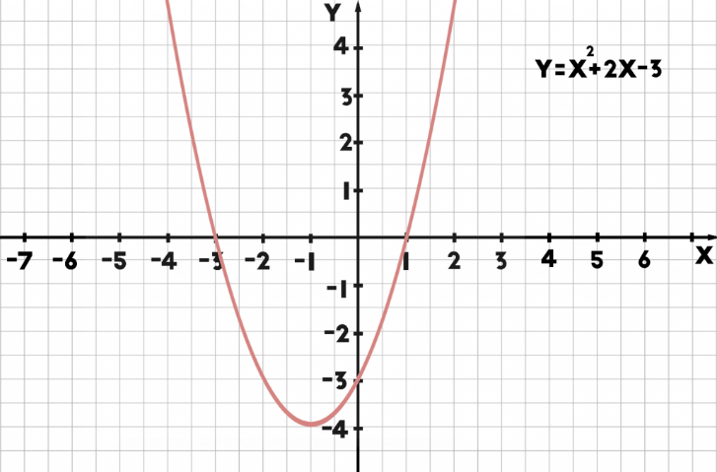

* vertex: _______________________________
* axis of symmetry: ________________________
* zeros: ___________________________________
* domain: ________________________________
* range: __________________________________
* increasing: ______________________________
* decreasing: _____________________________
* rate of change $-2 ≤x≤0$: ______________

**Describe the transformation & write an equation for each function in vertex form.**

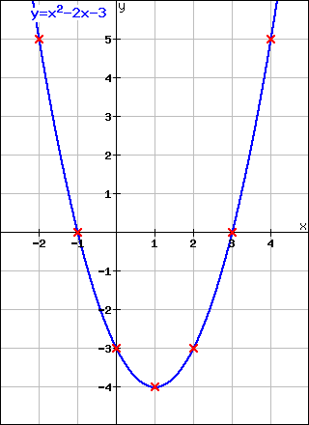

* description: ___________________________ ______________________________________________________
* equation: _____________________________



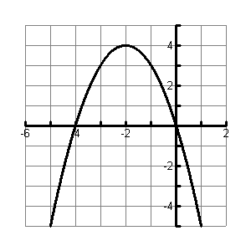

* description: ___________________________ ______________________________________________________
* equation: _____________________________



**Describe the transformations to the parent graph for each equation.**



$f\left(x\right)= \frac{1}{2}x^{2}+3$

$f\left(x\right)= -3 {\left(x-2\right)}^{2}-5$

**Write the quadratic equation of the graph that has been…**

1. shifted down 4 units and left 9 units.
2. reflected over the x-axis and has a vertical shrink (horizontal stretch) by a factor of 1/5.

**Sketch the quadratic function.**

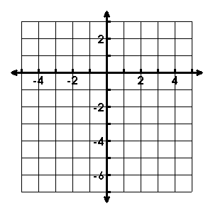

**Change the following equations to standard form. SHOW ALL WORK!**



$y={(x+4)}^{2}+6$

$y=3{(x-1)}^{2}+4$

**Change the following equations to vertex form. SHOW ALL WORK!**

$y= x^{2}-12x+10$

$y=4x^{2}+16x-4$

**Graph the function given below and then, answer the questions in comparing the 2 functions.** 

5



1. Find the vertex for both functions.
2. Which function reached a higher point?
3. Which function had the greatest rate of change from

x1 = 0 to x2 = 2?

*g(x)*

**Multiple Choice**

1. What is the vertex and axis of symmetry of the quadratic: $y= -2{\left(x+3\right)}^{2}-6$?
$\left(-3, 6\right) , x=3$

$\left(-3, -6\right) , x=-3$

$\left(3, 6\right) , x=-2$

$\left(-3, -6\right) , x=-2$

2. What is the vertex and axis of symmetry of the quadratic: $y=6x^{2}-24x+35$?

$\left(2, 11\right);x= 2$

$\left(-2, 11\right);x= -2$

$\left(2, -11\right);x= -11$

$\left(-2,- 11\right);x= 11$

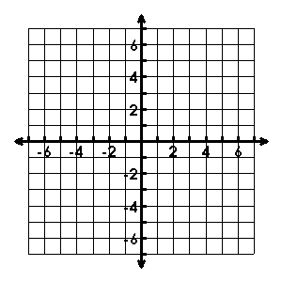

For #19 & 20, use the information for a given quadratic function:

1. Sketch the graph to the right using the information below

Domain:  Increasing: $(2,∞)$ Range:  Decreasing: $(-∞,2)$

There is no vertical or horizontal stretch (a = 1)

1. What is the equation for the axis of symmetry?
2. x = -4
3. x = 0
4. x = 2
5. x = 3
6. What is the end behavior for the graph of ?
7. x 🡪 ∞, f(x) 🡪 ∞ and x 🡪 - ∞, f(x) 🡪 ∞
8. x 🡪 ∞, f(x) 🡪 -∞ and x 🡪 - ∞, f(x) 🡪 -∞
9. x 🡪 ∞, f(x) 🡪 ∞ and x 🡪 - ∞, f(x) 🡪 -∞
10. x 🡪 ∞, f(x) 🡪 -∞ and x 🡪 - ∞, f(x) 🡪 ∞
11. Which of the following graphs best represents the function: ?
12. 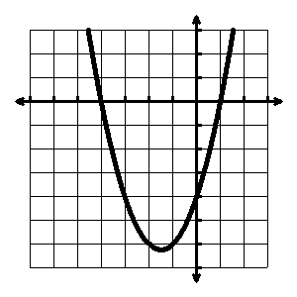
13. 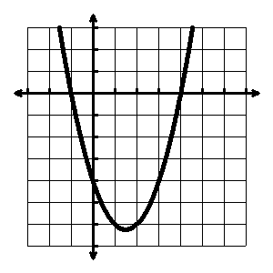
14. 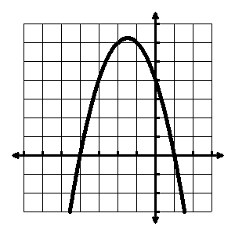
15. 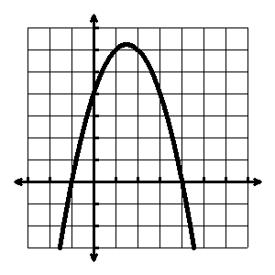



23. Which of the following graphs best represents the function:

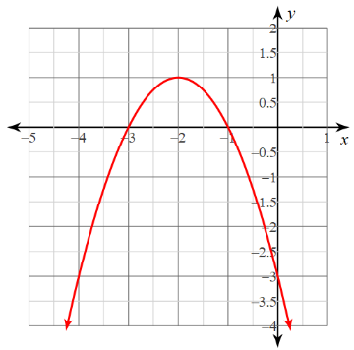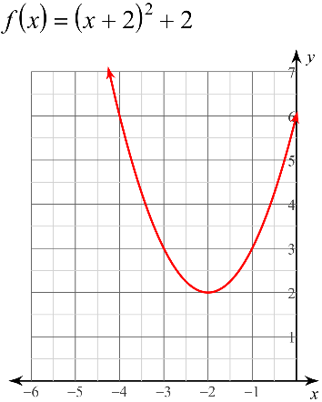

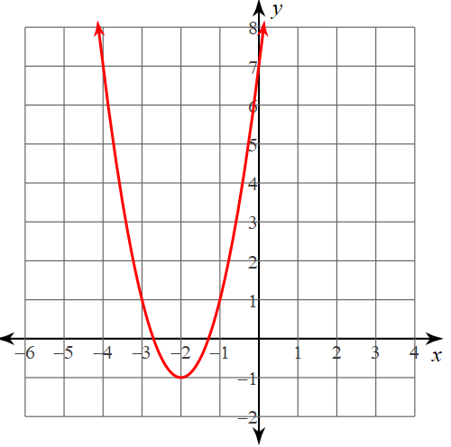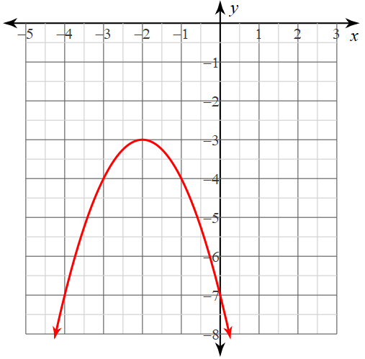

24. A ball is hit into the air from a height of 4 feet. The function h(t) = -16t2 + 120t + 4 can be used to model the height of the ball where *t* is the time in seconds after the ball is hit.

a. How long before the ball hits the ground?

25. Elizabeth reads about a rocket whose path can be modeled by the function

h(t) = -16t2 + 180t + 15.

a. How long will it take the rocket to reach its maximum height?

b. What is the maximum height of the rocket?