Name: ________________________________________________ Date: _______________________

**Unit #10 Review**

In a bowl of marbles, there are 10 red ones, 6 green ones, and 8 blue ones.

1. If a marble is chosen at random from the bowl, find P(red one or a blue one)?
2. If two marbles are chosen at random with replacement, find P(red and a blue)?
3. If two marbles are chosen at random without replacement, find P(they are both red)?

|  |  |  |  |  |  |  |
| --- | --- | --- | --- | --- | --- | --- |
| + | 1 | 2 | 3 | 4 | 5 | 6 |
| 1 |  |  |  |  |  |  |
| 2 |  |  |  |  |  |  |
| 3 |  |  |  |  |  |  |
| 4 |  |  |  |  |  |  |
| 5 |  |  |  |  |  |  |
| 6 |  |  |  |  |  |  |

A person rolls two dice, one after the other.

1. P(even sum) **or** P(sum of 9)
2. P(odd sum) **or** P(sum less than 5)
3. What is the probability that the sum of two rolls

is an even number **given** at least one of the rolls is a 4?

A card is chosen from a standard deck of cards. The drawer is looking for clubs and face cards.

|  |  |  |  |
| --- | --- | --- | --- |
|  | Club | Not a Club |  |
| Face card | 3 | 9 |  |
| Not a face card | 10 | 30 |  |
|  |  |  |  |

1. Find P(Club)
2. Find P(Club | Not a Face Card)
3. Find P(Club  Face Card)
4. Find P(Not a Club  Not a Face Card)
5. Are the events Club and Not a Face Card Independent of each other?
6. In a Coordinate Algebra class, 22 students were male and 10 students were female. Out of those students, 11 of the guys and 4 of the girls passed the EOCT. If a person is chosen at random from the class, what is the probability of choosing a girl or a person that did NOT pass the EOCT?

|  |  |  |  |
| --- | --- | --- | --- |
|  | Pass | Not Pass |  |
| Male |  |  |  |
| Female |  |  |  |
|  |  |  |  |

Of 500 athletes surveyed, 300 were male and 20 were left-handed. Only 8 of the left-handed athletes were female.

2. What is the probability that an athlete was male or was left-handed?

In a survey of 450 people, 200 of whom are female, it was found that 225 prefer chocolate ice cream including 99 males. Use this information to complete the table below.

|  |  |  |  |
| --- | --- | --- | --- |
|  | Males | Females |  |
| Vanilla |  |  |  |
| Chocolate |  |  |  |
|  |  |  | 450 |

1. The person likes chocolate.
2. The person like vanilla, given they are male.
3. The person likes vanilla or is a female.
4. Are being a male and liking chocolate independent events?

Use the Venn diagram to find the following probabilities.

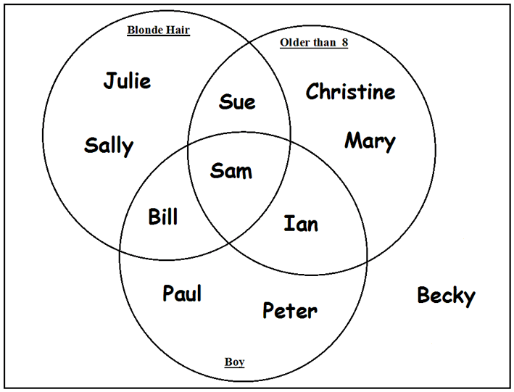

1. P(blonde hair)
2. P(blonde hair Boy)
3. P(Older than 8 Boy)
4. P(Older than 8 Boy)’
5. The probability of a randomly chosen boy playing basketball is 0.30. The chance that a boy plays both basketball and football is 0.05. The chance that a boy plays football is 0.25. What is the probability that a randomly chosen boy plays basketball or football?
6. Assume that the following events are dependent:

* The probability that a high school student eats breakfast is 0.8.
* The probability that a high school senior will eat breakfast and get over 6 hours of sleep is 0.2.

What is the probability that a high school senior will get over 6 hours of sleep, given that the person ate breakfast?