GSE Honors Geometry Name _____________________________  
Review WS #7-3 Date ________________

Determine whether the polygons are similar. If so, write the similarity ratio and a similarity statement. If not, explain why not.

1. parallelograms EFGH and TUVW 2. CDE and LMN

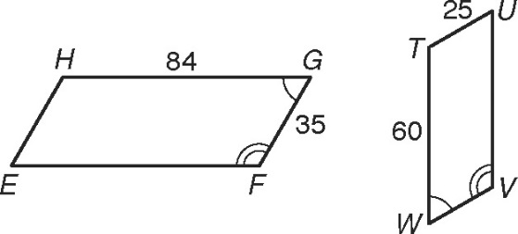 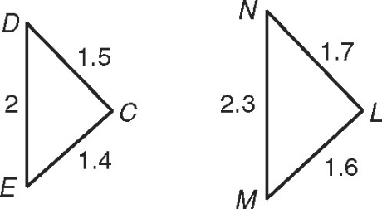

The polygons in each pair are similar and drawn to scale. Find the missing side length.

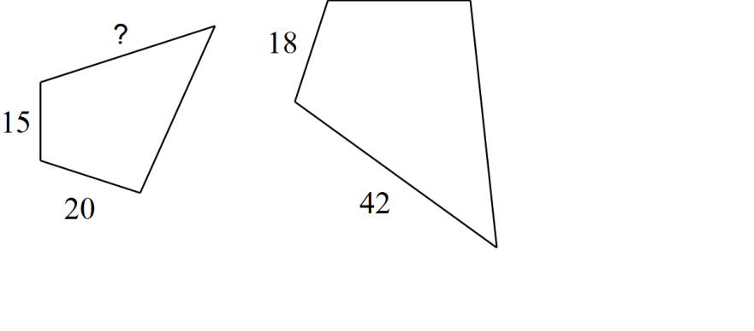3. 4.

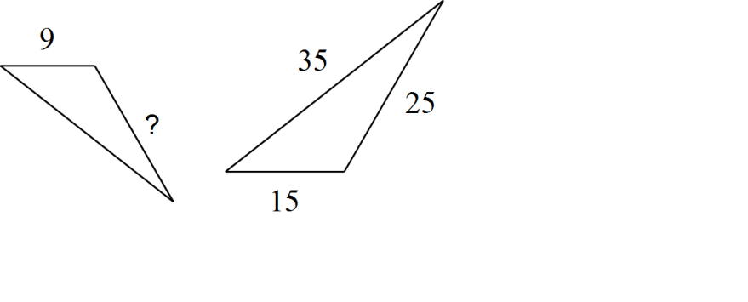

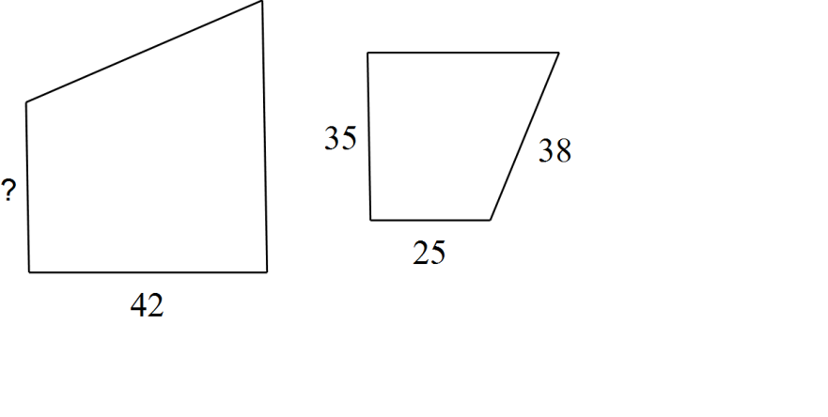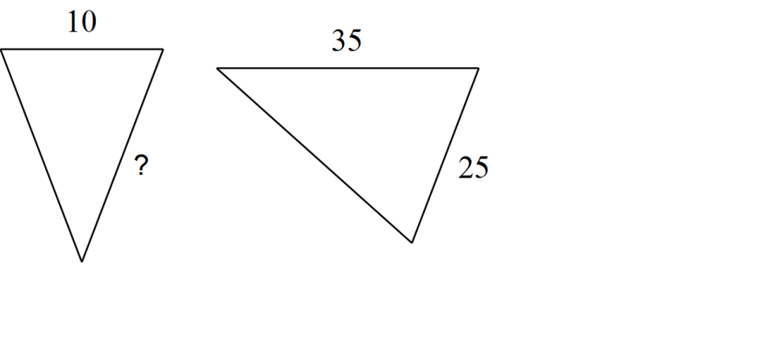5. 6.

7. 8.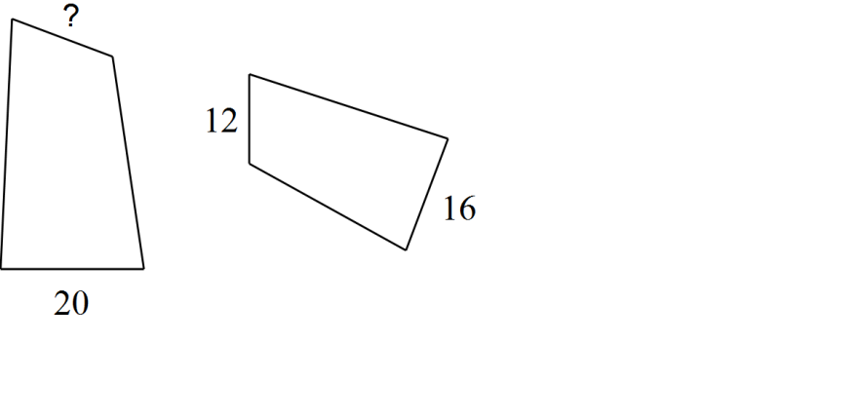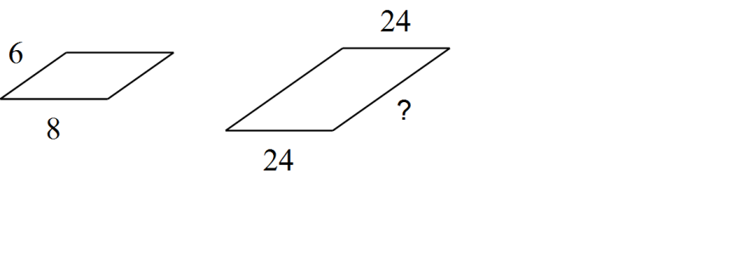

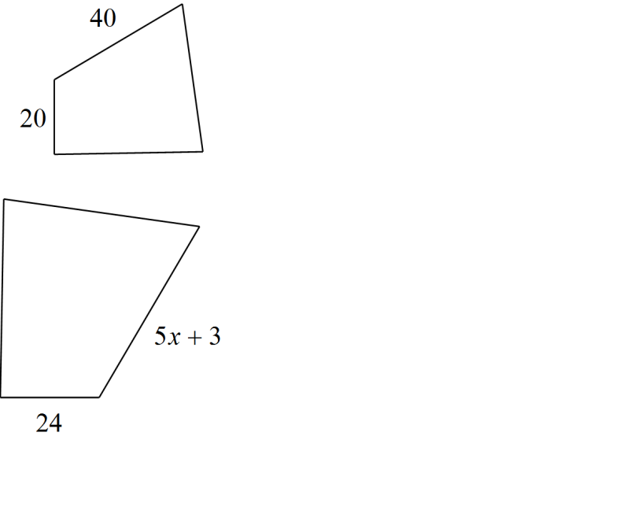The polygons in each pair are similar and drawn to scale. Solve for x.

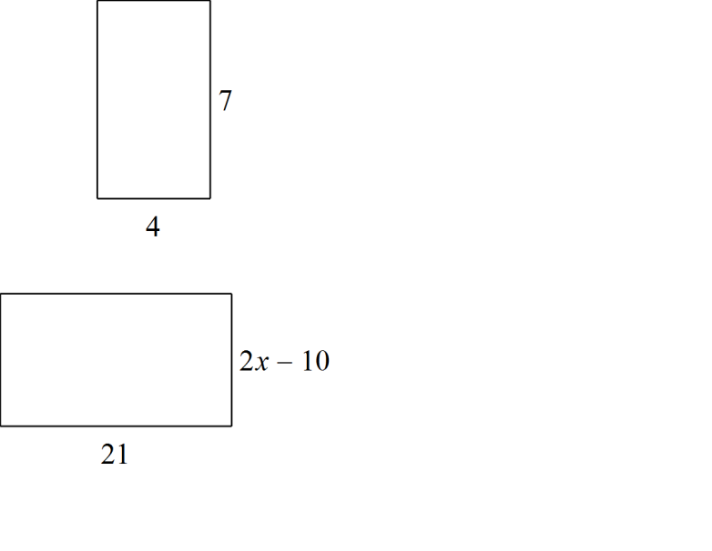9. 10.

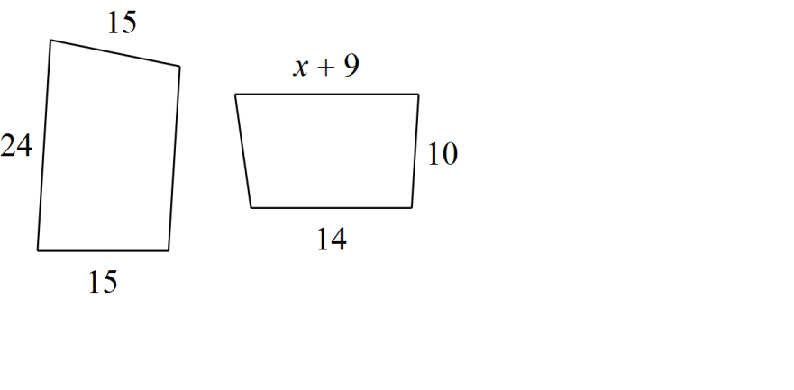

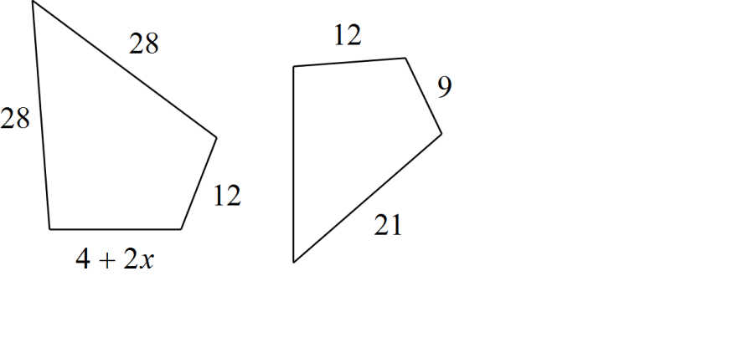11. 12.

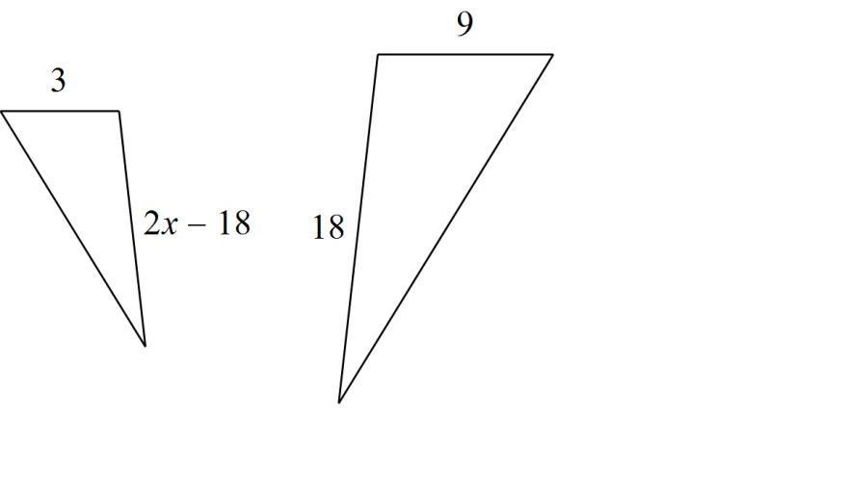

*x* - 3

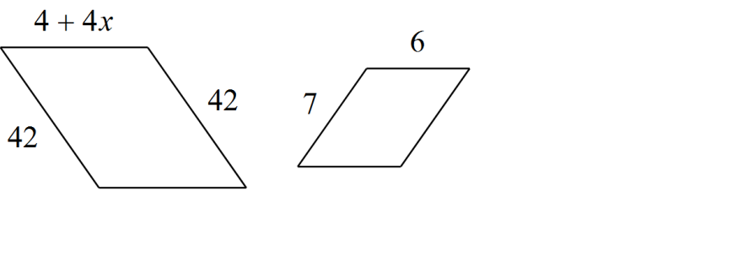13. 14.

2*x* - 9

15. QRS  TUV. Find the value of y.

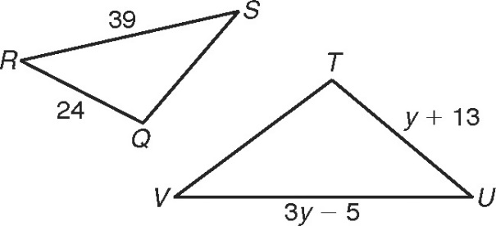

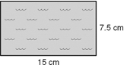16. A diagram of a new competition swimming pool is shown. If the longer side of the pool is 25 meters, find the area of the actual pool.

17. The ratio of a model scale die cast motorcycle is 1:18. The model is 5.5 inches long. What is the length of the actual motorcycle in feet and inches?

**Indicate whether the statement is true always, sometimes, or never (A, S, or N).**

18. If two triangles are similar, then they are congruent.

19. If two triangles are congruent, then they are similar.

20. An obtuse triangle is similar to an acute triangle.

21. Two right triangles are similar.

22. Two regular polygons are similar.

23. Two equilateral triangles are similar.

24. Two rectangles are similar if neither is a square.

25. PRQ [P(-8, 4), Q(-4, 8), R(4, 4)] is transformed by the following: . Identify the coordinates of P'Q'R'.

26. Graph the image of MNP after a dilation with scale factor 3.

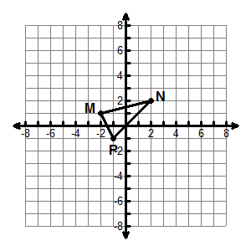

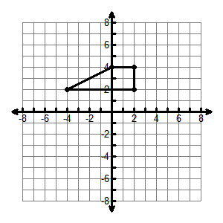28. Dilate given the scale factor 2 and center of dilation (-2, 1).

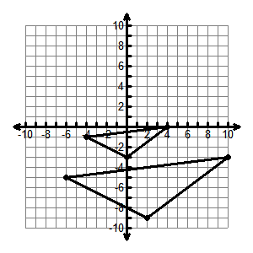30. Identify the center of dilation and the scale factor of the reduction.

27. Graph the image of ABC after a dilation with scale factor 2/3.

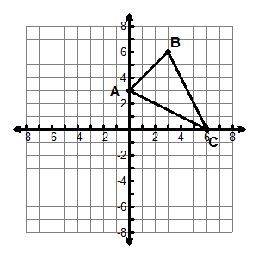

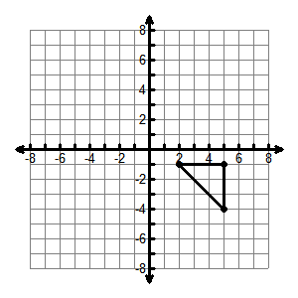29. Dilate given the scale factor  and center of dilation (-1, 2).

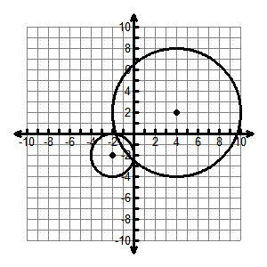31. Identify the center of dilation and the scale factor of the enlargement.