Name: ____________________________________________________________ Date: ________________________

**Unit 3 Test Review**

**Similar Triangles:**

1. In the figure, ΔRST ~ ΔXYZ.

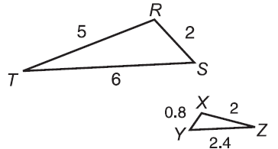

1. Find the scale factor of ΔRST to ΔXYZ.
2. Find the perimeter of both triangles. What is the

ratio of the perimeters of the 2 triangles?

1. Dilations:
2. Draw a dilation with k = 2 b) Determine the scale factor, k = ____

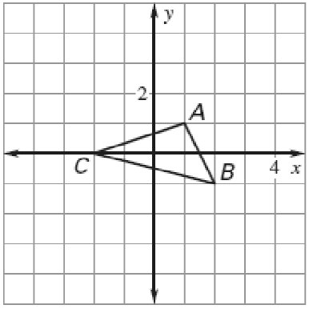 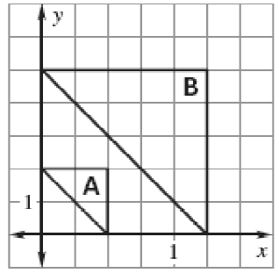

1. Find the length of the missing side(s).

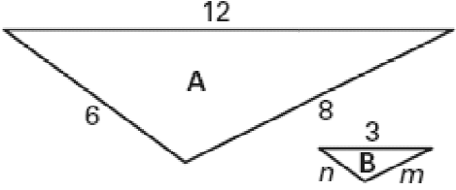

1. b)

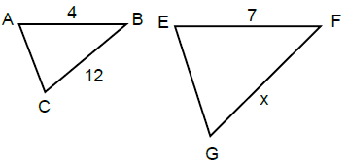

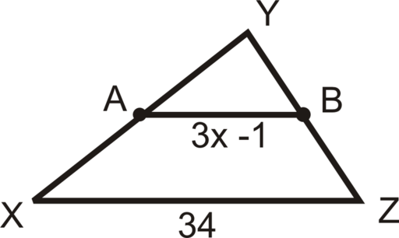

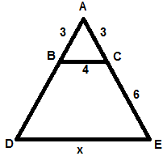

c) d)

1. Determine if the following triangles are similar. If so, give the postulate and similarity statement.

a) ABC ~ ______ by______ b) GHI ~ ______ by______ c) MNO ~ ______ by______

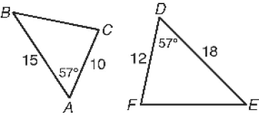 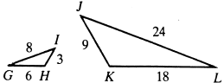 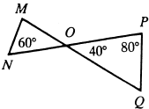

1. If a 42.9 ft tall flagpole casts a 253.1 ft long shadow, then how long is the shadow that a 6.2 ft. tall woman casts?

**SOHCAHTOA:**

6) a) Find the 3 trig ratios from Angle A and Angle B.

1. How do the ratios compare for the two angles?

7) **Draw CAT where ∠ATC = 90°, CA = 53, and CT = 28.**

1. What is the length of AT?
2. What is sin C? c) What is tan A?

8) **Draw ABC where ∠B = 90° and .**

1. What is the length of AB?
2. What is tan A? c) What is cos A?

9) Solve for the missing side or angle using Trig Ratios (sin, cos, tan).

**a) b) c)**

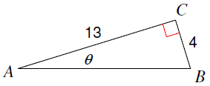 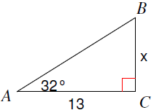 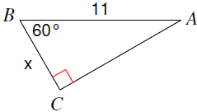

**d) e) f)**

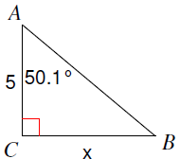 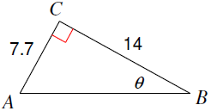 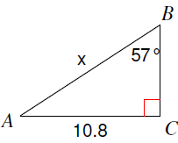

1. An 8 foot ladder is leaning against a wall so that the base is 5 feet from the base of the wall. What angle does the ladder make with the ground? Round to the nearest tenth.
2. A surveyor is standing 25 ft from a building and is looking at the top with an angle of elevation of 65°. If his eye height is 6 ft, how tall is the building? Round to the nearest tenth.
3. A kite is being flown using 150 yards of string. The kite has an angle of elevation with the ground of 65 degrees. How high above the ground is the kite?