**Name: ______________________________________________ Date: ____________________________________**

**Is  tangent to 🞊C? Explain your reasoning. Show work!**



25

1. 

**For each 🞊, find the value of *x*. Assume that segments that appear to be tangent are tangent.**

1. 
2. 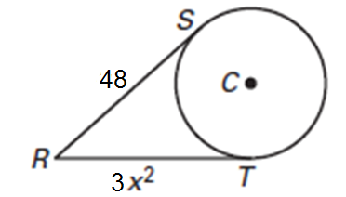

x

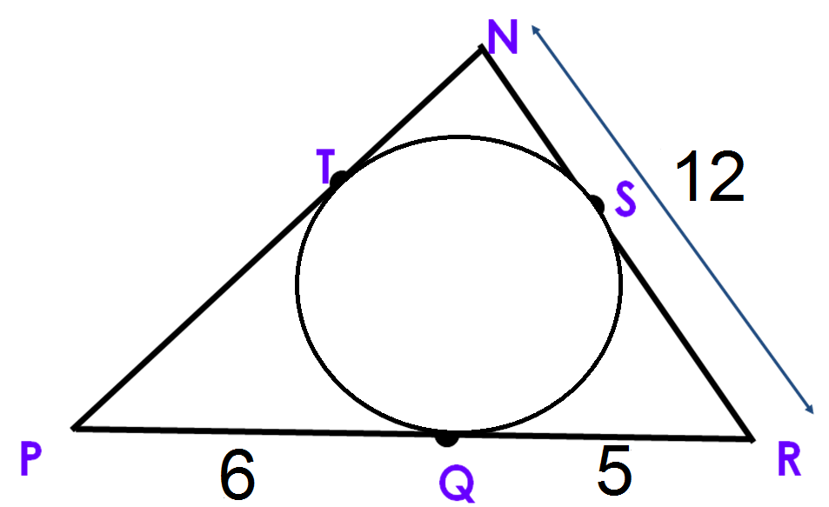

1. 
2. 
3. 





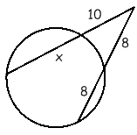

2. 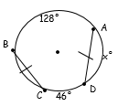
3. 

**x**

**5**

**13**

1. 

**Find the volume of the following figures.**

1. 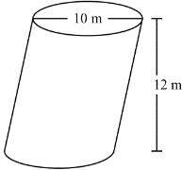
2. 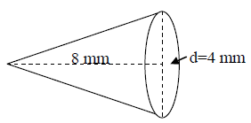
3. 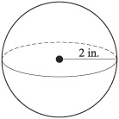
4. 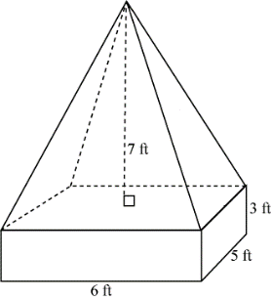
5. A prism has a square base with a width 3 cm. Its volume is 90 cm3. A square pyramid has the same width for its base and the same height as the prism. What is the volume of the pyramid?

1. Collin is going to change the oil in his Jeep. He has two funnels. A has a diameter of 6 inches and is 5 inches deep. B has a diameter of 5 inches but is 7 inches deep. He wants to use the funnel with the greatest volume to minimize the chance of spilling the oil. What are the volumes of the funnels? Which one should he use A or B?