Unit 4 Review Name____________________________
1. Match each characteristic to the correct graph shown. Write the letter in the box below the correct graph. (1 point each)
Each graph will have 4 correct characteristics.
Some characteristics may be used more than once or not at all.
A) asymptote: $y=-1$ | B) asymptote: $y=0$ | c) asymptote: $y=3$
D) Domain: $(-∞, ∞)$ | E) End behavior:  As $x→-∞, f\left(x\right)→∞$  As $x→∞, f\left(x\right)→-1$ | F) Interval of Decrease: none
G) Negative Interval: none | H) Positive Interval: $(-∞,1)$ | I) Range: $(-1, ∞)$
J) y-intercept: $\left(0, 1\right)$ | K) y-intercept: $\left(0, 2\right)$ | L) y-intercept: $(0, 3)$

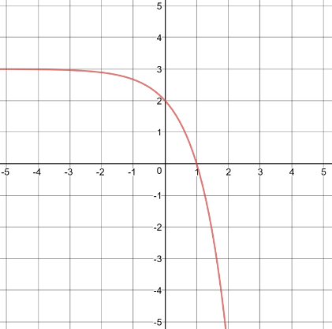 |  |  |  | 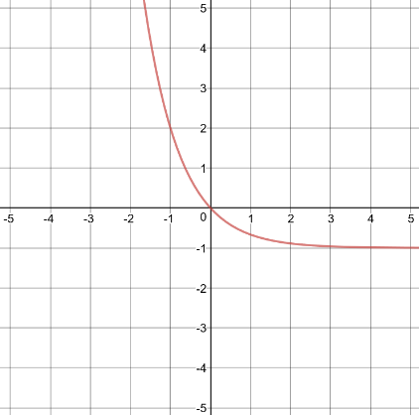 |  |  |  | 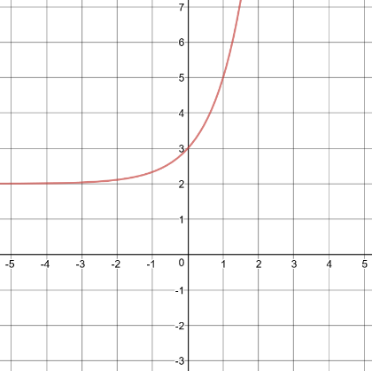
WRITE THE LETTERS OF THE CHARACTERISTICS HERE: |  |  |  | WRITE THE LETTERS OF THE CHARACTERISTICS HERE: |  |  |  | WRITE THE LETTERS OF THE CHARACTERISTICS HERE:

Graph each exponential function.
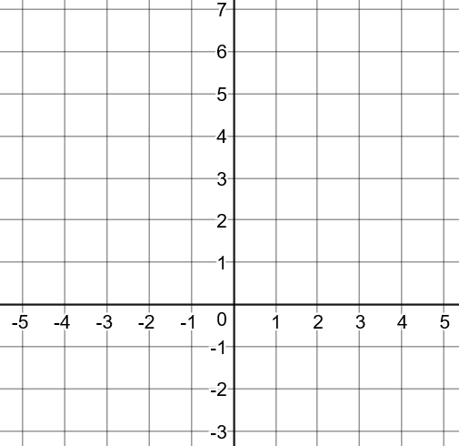
2. $y=\frac{1}{2}{(2)}^{x}+1$ 3. $y=2{\left(\frac{1}{3}\right)}^{x+1}$

$$x$$ | $$y$$
-2
-1
0
1
2

$$x$$ | $$y$$
-2
-1
0
1
2

4. The flamingo population at the zoo was 38 in 2002 and is increasing at an annual rate of 2.3%. If this growth rate continues, what will the approximate population of flamingos be in the year 2020?

5. How does the graph of the function $y=3^{x-4}$ compare to the parent function $y=3^{x}$?

6. The growth pattern of the Gremlin population can be described by the function $y=4{(2)}^{x}$, where x is the number of days.
Which statement describes this situation?
- The number of Gremlins multiplies by 4 each day.
- The number Gremlins is divided by 2 each day.
- On the first day, the number of Gremlins was 4.
- On the first day, the number of Gremlins was 2.

7. Which of the following is a geometric sequence? SELECT ALL THAT APPLY
- 12, 10, 8, 6, …
- 1, -2, 4, -8, …
Find the common ratio for each geometric sequence you checked.
- 3, 6, 9, 12, …
- 3, 6, 12, 24, …
- 64, 32, 16, 8, …
- 10, 20, 30, 40, …
- 28, -14, 7, -3.5, …

8. What is the rate of change over the interval $0≤x≤1$?
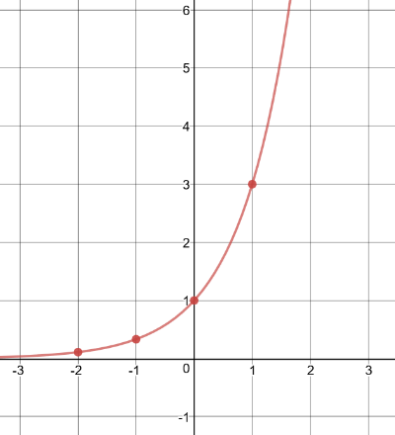
a. b. c. $f\left(x\right)=2{(4)}^{x}$
$$x$$ | $$y$$
-2 | .0625
-1 | .25
0 | 1
1 | 4
2 | 16

9. Cedric has 2 imaginary friends. Each day the number of imaginary friends triples.
Day 1 Day 2 Day 3

a. Write the first 5 terms of the sequence: _____, _____, _____, _____, _____
b. Write an explicit rule for the sequence.

c. How many imaginary friends will Cedric have after 10 days?

10. Describe the transformations on the parent function, given the transformed function.
Parent Function | Transformed Function
$$y={\left(\frac{3}{2}\right)}^{x}$$ | $$y={-2\left(\frac{3}{2}\right)}^{x+7}-3$$

11. The recursive formula for a geometric sequence is $a_{n}=6(a_{n-1})$ where $a_{1}=\frac{1}{2}$.
What are the first 5 terms of the sequence?

12. Given the function $f(x)=2500{(.42)}^{x}$, determine the following:
a. Growth or Decay
b. Growth/Decay Rate
c. $f(10)$

13. Given the geometric sequence 3, -15, 75, -375, …
a. Write an explicit equation to represent the sequence.

b. Find $a_{7}$

14. Describe the transformations of the function $f\left(x\right)=3^{x}$ to create the function $g\left(x\right)$ shown.
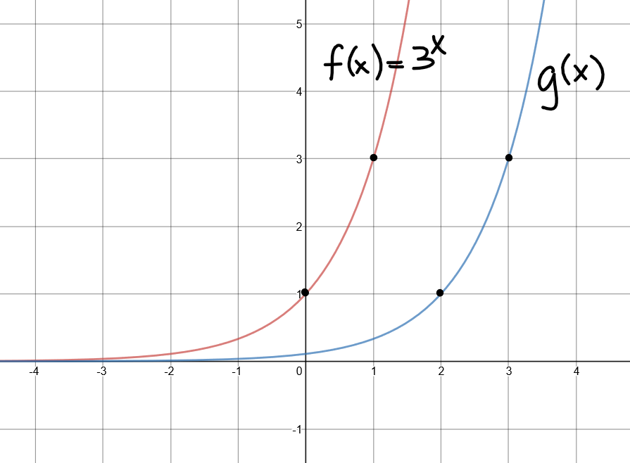

15. Jimmy deposits $3500 in an account that earns 3.2% interest per year.

- Write an exponential function to represent the scenario.

- How much money will he have in this account after 5 years?

SOLUTIONS:
- C, D, H, K A, D, E, I D, F, G, L

- See graph

- See graph

- 57 flamingos

- Shift horizontally 4 units right

- C.

- 1, -2, 4, -8, … r = -2

3, 6, 12, 24, … r = 2

64, 32, 16, 8, … r = ½

28, -14, 7, -3.5, … r = - ½

- a) 3 b) 2 c) 6
9. a) 2, 6, 18, 54, 162 b) $a_{n}=2{(3)}^{n-1}$ c) 39,366 imaginary friends
10. reflection over the x-axis, stretch by a factor of 2, shift left 7 units and down 3
11. ½, 3, 18, 108, 648
12. a) Decay b) 58% c) f(10) = 0.427

