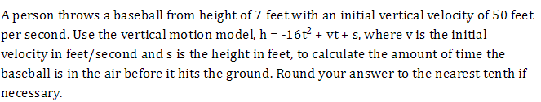
1.

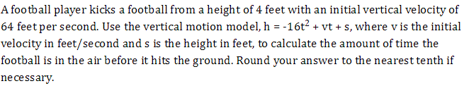
2.

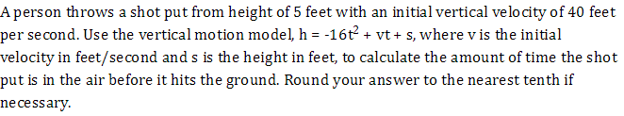
3.

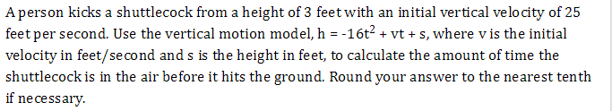
4.

5. You drop a rock off a cliff 600 feet high. The equation to represent the fall of the rock is
h(t) = ${-16t}^{2}+600$ . How long will it take for the rock to hit the ground?

6. A monkey in a tree dropped a banana 96 feet to the ground. The number of seconds, t , it took the banana to reach the ground is represented by h(t) = ${-16t}^{2}+96$ . How many seconds did it take the banana to reach the ground?

7. A girl at a football game dropped her palm-palm 115 feet from the stands to the ground. The number of seconds, t , it took the palm-palm to reach the ground is modeled by h(t) = ${-16t}^{2}+115$ . How many seconds did it take the palm-palm to reach the ground?

8. The expression ${-x}^{2}+80x-700$ represents a company’s profit for selling x items. For which number(s) of items sold is the company’s profit equal to 0?

